 Ragan A. Squier
ESF Board of Trustees
Secretary to the Board

M E M O R A N D U M

TO: Members of the ESF Board of Trustees
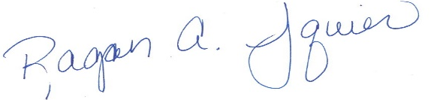
FROM: Ragan A. Squier
Secretary to the Board of Trustees

DATE: August 31, 2022

SUBJECT: Official Notice of the September 22, 2022 ESF Board of Trustees Meeting

Please be advised that a meeting of the ESF Board of Trustees will be held on Thursday, September 22, at 9:00 AM at the following location:
224 Bray Hall | 1 Forestry Drive | Syracuse, N.Y. 13210 U.S.A. | P. 315.470.6681 | F. 315-470-6977 | president@esf.edu | esf.edu

SUNY ESF
408 Baker Laboratory
1 Forestry Drive
Syracuse, NY

The meeting will be livestreamed and recorded in compliance with Open Meetings Law.

