APPLICATION COVER PAGE

Edna Bailey Sussman Fund

Applicant’s name: Alexander Young Date: January 5th, 2018

Address: 908 Lancaster Avenue ESF program: Forestry and Natural
Syracuse, NY 13210 Resource Management

Telephone number: (410) 274-0519 Faculty Sponsor: Dr. Ruth D. Yanai

Email: aryoung@syr.edu

Internship organization and address:
National Ecological Observatory Network
1685 38th St., Suite 100
Boulder, CO 80301

Internship objectives:
Align remotely sensed tree canopies with field observations and foliar chemistry data in Bartlett Experimental Forest, New Hampshire. I will compare the spectral profiles of trees that have been fertilized for seven years to identify remotely sensed signals of tree health and/or decline across the northern hardwood landscape.

Period of work: 21 May 2018 through 24 August 2018 (14 weeks)

Salary provided by organization: None

Amount requested from Sussman Fund: $7,350.00

Faculty Sponsor Applicant


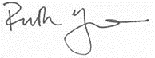
(Signature) (Signature)

PROPOSAL (494 words)

While forests across the world experience unprecedented rates of environmental change, our ability to observe and monitor these changes is also increasing rapidly. It is difficult to collect foliage from the top of tree crowns and expensive to analyze the resulting leaves for foliar chemistry. Although remote sensing offers the unique ability to observe every tree within a research plot, the resulting data are strictly empirical and require calibration with field measurements. At Bartlett Experimental Forest, we happen to have the perfect field experiment that is co-located with one of twenty National Ecological Observatory Network (NEON) sites. NEON sites collect continuous atmospheric data and will be flown annually with state of the art one-meter resolution airplane sensors for the next 30 years.

With support from the Edna Bailey Sussman Foundation, I propose to investigate the spectral properties of trees that have been fertilized for seven years with nitrogen, phosphorus, and calcium, as part of a larger study on Multiple Element Limitation in Northern Hardwood Ecosystems. My project will be conducted as an internship with NEON’s airborne remote sensing lead: Dr. Nathan Leisso. My internship objective is to remotely sense the nutrient status of tree canopies in Northern hardwood forests by aligning field and airplane tree crown observations. I will examine how individual trees’ spectral profiles respond to nutrient additions to better assess the landscape for remotely sensed signals of tree health and/or decline. This research has the potential to determine which forested areas are most in need of conservation and management efforts.

I will make use of nine existing nutrient manipulation stands in Bartlett Experimental Forest, New Hampshire, USA and data collected from NEON’s Airborne Observatory Platform. Within each stand there are 50 m x 50 m plots that receive no treatment (control), nitrogen (30 kg N/ha/yr), phosphorus (10 kg P/ha/yr), both nitrogen and phosphorus at the same rates, and in 3 stands, calcium (1150 kg/ha). The location of tree crowns will be verified over a 14 week period (May 21st–August 24th). Field observations of tree crown locations will verify computer-generated tree crowns collected by a NEON airplane using lasers and reflected light energy. This analysis will make it possible to detect individual tree crown nutrient status, and infer the health and resiliency of each tree.

My internship will be supervised by Dr. Nathan Leisso, an expert on remote sensing and plant vegetation identification at NEON’s headquarters in Boulder, Colorado. Dr. Leisso will assist with the design of the investigation and will oversee the execution of this internship by email, telephone, and scheduled conference calls. This project is related to my current thesis research on sugar maple canopy response to nutrient treatments in northern hardwood ecosystems. Results will be presented at the annual Hubbard Brook Cooperator’s Meeting on July 12^{th,} 2018 and prepared for publication in a peer-reviewed scientific journal. The Edna Bailey Sussman Foundation will be recognized for its support of this project in all written and oral products of this research.

LETTER FROM FACULTY SPONSOR

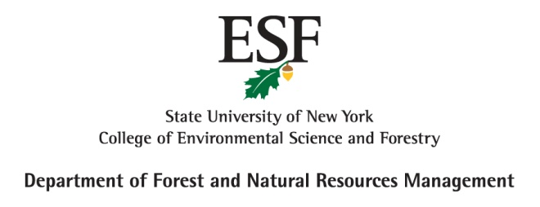
January 5, 2018

To the Edna Bailey Sussman Foundation (c/o SUNY-ESF)

I am writing in support of Alexander Young’s application for a Sussman Internship with NEON, the National Ecological Observatory Network. NEON represents a $469 million investment by the National Science Foundation, and their 20 intensive monitoring sites include the Bartlett Experimental Forest in New Hampshire, where Alex has been conducting research for his MS thesis. While Alex has been laboriously climbing trees to study the response of forest canopies to experimental manipulation of nitrogen and phosphorus availability, NEON has been flying over the forest with state-of-the-art remote sensing technology. Alex’s proposed internship would combine NEON’s remotely sensed spectra of tree canopies with the actual foliar chemistry that we have measured using traditional laboratory techniques. The project will require matching up the maps that we have made on the ground of tree locations with the crown maps created by NEON. Since the research project that Alex is working in at Bartlett is the only continuing full factorial NxP manipulation experiment in northern hardwood forests, I am confident that novel insights can be gained from this partnership.

The internship will start on May 21 and run through August 24, 2018. The internship will be supervised by Dr. Nathan Leisso, who leads the remote sensing efforts of the National Ecological Observatory Network. Since Dr. Leisso is based in Boulder CO, where NEON is headquartered, their interactions will take place primarily via email, telephone, and teleconference. I am confident of NEON’s interest in Alex’s project (they have been asking for researchers to propose uses for the data they are collecting) and of Alex’s ability to communicate with Dr. Leisso (he initiated this relationship and Leisso took it though all proper channels). NEON also has personnel on the ground at Bartlett, who will take an interest in this application of their data. The best and final evaluation of the project will be conducted by the peer reviewers of the resulting publication.

I hope that this exciting project will merit selection by the Sussman Foundation.
Please contact me if I can be of any further assistance in this matter.

Sincerely,
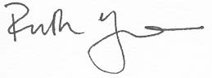
Ruth D. Yanai

Professor
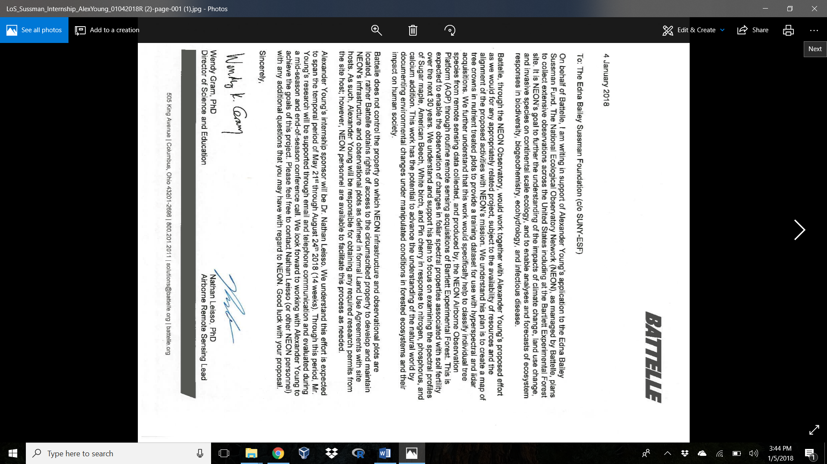
LETTER FROM INTERNSHIP SPONSOR

ESF GRADUATE TRANSCRIPT

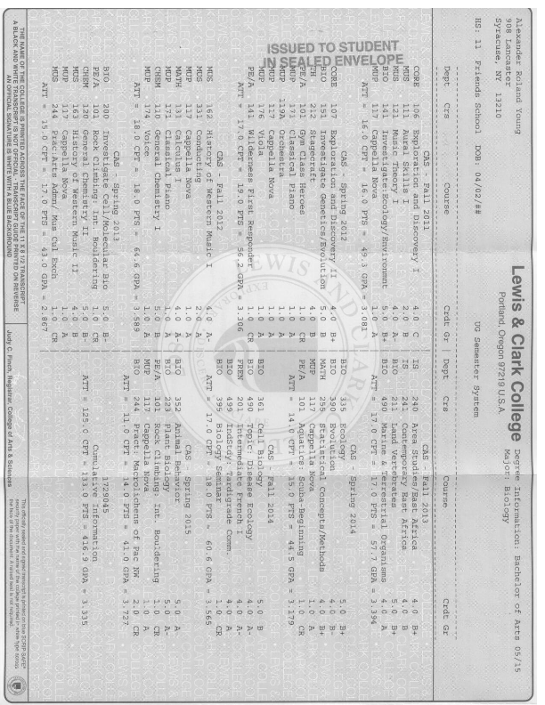
UNDERGRADUATE TRANSCRIPT
CURRICULUM VITAE

Alexander R. Young

(410) 274 – 0519 | 908 Lancaster Avenue, Syracuse NY, 13201 | aryoung@syr.edu

EDUCATION
Master of Science candidate: Forest Resource Management January 2017–present
State University of New York College of Environmental Science and Forestry, Syracuse NY
Thesis title: “Sugar maple canopy response to nutrient addition”
Advisor: Professor Ruth D. Yanai
Bachelor of Arts: Biology Major May 2015
Lewis & Clark College, Portland, Oregon

PUBLICATIONS
Young, A., Miller, W., Lowman, M. 2016. Tardigrades of the Canopy: Milnesium swansoni sp. nov. (Eutardigrada: Apochela: Milnesiidae) a new species from Kansas, U.S.A. Zootaxa. 4071(5).
Young, A., Clifton, K. 2015. Tardigrades inhabit lichen and moss in Smith Rocks State Park, Oregon. Bulletin of the California Lichen Society 22(2).

PROFESSIONAL EXPERIENCE
SUNY College of Environmental Science and Forestry. Syracuse, NY Fall 2017
Graduate Teaching Assistant: Watershed Ecology & Management
- Designed quizzes to assess students’ engagement with course topics
- Held twice weekly office hours to clarify and review class content with students
- Graded written work for 81 students and graphed class scores to view grade distribution

Multiple Element Limitation in Northern Hardwood Ecosystems. Bartlett, NH Summer 2017 Field Crew Leader
- Oversaw field operations and scheduling of 14 undergraduate and graduate researchers
- Organized a research team to collect leaves from 12 Sugar Maple canopies
- Utilized mapping-grade GPS to precisely locate plot corner locations

SUNY College of Environmental Science and Forestry. Syracuse, NY Spring 2017
Graduate Research Assistant
- Analyzed leaf chemistry across 4 collection trips to view foliar resorption rates
- Guided leaf identification by high school students to record annual litter production
- Performed laboratory techniques to add to existing long-term datasets

Bartlett Tree Experts. Baltimore, MD Fall 2016
Production Arborist
- Learned how to prune urban trees to improve tree health and property aesthetics
- Abided by OSHA safety ordinances to promote site safety for general public and workers

United States Geological Survey. Sequoia National Park, CA Summer 2016
Biological Field Technician
- Assessed 34 sites for disease and digitally recorded detailed mortality reports
- Identified bark beetle galleries and fungal pathogens by removing bark
- Mapped and installed research plots with precise GPS points to align remote sensed data

California Academy of Sciences. San Francisco, CA Spring 2016
Accession Technician Specialist
- Identified, imaged, and accessioned 8,000 tardigrade specimens to digitize the collection
- Used morphometric analyses to view population dynamics of tardigrade communities

Siskiyou Biosurvey Company. Six Rivers, CA Fall 2015
Primary Investigator Canopy Meiofauna
- Designed explorative investigation to view tardigrade, nematode, and rotifer ecology
- Identified epiphyte and micro-animal specimens using spot tests and morphometry

NSF REU “Tardigrades of the Canopy”. Baldwin City, KS Summer 2015
Canopy Research Assistant
- Described Milnesium swansoni sp. nov (Young et al. 2016) and its canopy distribution
- Taught, oversaw and ensured safety of 8 undergraduates’ tree climbing field work
- Analyzed vertical stratification of 18 tardigrade species across 104 trees, in 8 field sites

NSF REU “Tardigrades of the Canopy”. Baldwin City, KS Summer 2014
Canopy Research Intern
- Ascended into trees with rope, harness, and helmet to collect epiphyte habitat
- Created 2,152 slides of tardigrade specimens to archive community composition

Lewis & Clark College. Portland, OR Spring 2014
Teaching Assistant
- Taught 2 laboratory sections, graded lab reports and exams, held weekly office hours
- Supervised 24 undergraduates during experiential laboratory investigations

Lewis & Clark College. Portland, OR Fall 2014–Spring 2015
Biology Office Assistant
- Created flyers for visiting professors and “biology talk” series
- Proctored exams to accommodate student scheduling conflicts

College Outdoors: Lewis & Clark College. Portland, OR Fall 2011–Spring 2014
Trip Leader + Gear Repair Specialist
- Guided students through technical environments to build familiarity with natural world
- Restored functionality to outdoor equipment to reduce program costs
- Developed and taught ancient forest ecology clinics to promote forest conservation

Cylburn Arboretum. Baltimore, MD Summer 2012–Summer 2013
Senior Nature and Science Camp Councilor
- Guided 8-11 year old inner city Baltimore children to engage with natural environments
- Taught clean water curriculum to improve children’s understanding of reduce, reuse, and recycle

TREE CLIMBING VOLUNTEERING
Douglas-fir Swiss Needle Cast severity mapping August 2016
Oregon State University, Oregon Coast, OR
Giant Sequoia drought response field campaign July 2016
UC Berkeley, Sequoia National Park, CA
Public Tree Climbing Summer 2014–2015
Tree Climbing Kansas City, Olathe, KS

POSTERS
Young, A., Yanai, R., Minocha, R., Long, S. Sugar Maple Canopy Response to Nutrient Treatment. Forest Ecosystem Monitoring Cooperative, Burlington VT. December 15th 2017.
Young, A., Yanai, R., Minocha, R., Long, S. Specific leaf area and amino acids respond to nutrient amendments and canopy depth. Rochester Academy of Sciences, Rochester, NY. November 11th 2017.
Young, A., Miller, J. Villella, J., Emanuels, A., Carey, G., Miller, W. Nest Guests: Water bears inhabit vole nests in Douglas-fir canopies. SUNY-ESF Student Spotlight, Syracuse, NY. April 24th 2017.
Young, A., Miller, J. Villella, J., Emanuels, A., Carey, G., Miller, W. Tardigrades in Red Tree Vole Nests. New York Society of American Foresters, Syracuse NY. January 26th 2017.
Young, A., Tripp, R., Lowman, M., Miller, W. Tardigrades in the Canopy. 13th International Symposium on Tardigrada, Modena, Italy. June 23-26th 2015.
Young, A., Digital herbarium: lichens and beetles of Lewis & Clark College. Lewis & Clark Speaker Series. April 25th 2015.
Young, A. Miller, W. In the canopy with Tardigrades and wheelchairs. Sigma Xi International Conference, Phoenix AZ. November 7-8th 2014.
Young, A., Chappell, B., Miller, W. Tardigrades of the canopy: Milnesium sp. nov C. California Academy of Sciences, August 5th 2014.

PRESENTATIONS
Young, A., Yanai, R. How foliage traits respond to the vertical gradient and nutrient amendment. Hubbard Brook Cooperators of Science, NH, July 7th 2017.
Young, A. Miller, J., Villella, J., Carey, C., Miller, W. Meiofauna zonation in a Douglas-fir forest canopy. Northwest Scientific Association. April 2nd 2017.
Young, A. Tardigrades are Extremophiles in your back yard. Friends School of Baltimore Speaker Series. March 14th 2016.
Young, A. Lichens, Mosses, and Water Bears, Oh My! The Northwest Academy. Portland, OR. October 16th, 2016.
Young, A. Clifton, K. Tardigrades of Smith Rock State Park, OR. Northwest Scientific Association. Pasco, WA. April 3rd 2015.
Young, A. A closer look at tardigrades: your local extremophiles. Leadership & Entrepreneurship Public Charter High school. April 11th 2014.

GRANTS, AWARDS, AND CERTIFICATIONS
Cline Award: SUNY-ESF: Dept. Forest and Natural Resource Management Fall 2017
Graduate Student Travel Grant: SUNY-ESF Spring 2017
Wilderness First Responder: SOLO wilderness medicine institute May 2016
Advanced tree research & aerial rescue: Tree Climbing Planet May 2015
Kent Swanson Jr. Award: Lewis & Clark College Biology Department 2013 – 2015
Miller Science Award: Lewis & Clark College 2011 – 2015
Basic Tree Climber: Tree Climbers International June 2014
Open Water Diver: Scuba Schools International April 2014

TECHNICAL SKILLS
- Programming languages and mathematical packages: R, Python, SAS, Sigmaplot
- Microsoft office: Access, Excel, Powerpoint, Word
- Geospatial Information Systems: ArcGIS, QGIS, Google Earth Engine

BUDGET JUSTIFICATION

The proposed internship will begin Monday, May 21st 2018, and end Friday, August 24th, 2018. I will work 35 hours per week for the entire 14–week period. I am requesting a salary of $15 per hour.

$15.00/hour x 35 hours/week x 14 weeks = $7,350.00

Total Funds Requested: $7,350.00

