Action/Discussion Items
Figure 3 should be Figure 4.
Add page numbers.
Check usage of "stand" and "site." We think we should use "stand" because some of them are probably
Check Figure 5 ages.
Table 2 should have means across years.
Table 1 could go, archive it? Look into archiving with CJFR.

Color coded: Marty BB Mary Ruth

We want a table describing our sites. Name, date cut, lat, long, 10 columns for the 9 species plus other species, basal area. Two rows for each site, one for each inventory. We want to include the stems 2 to 10 cm.

Other places where we could include "other" species: Figures 1, 2, etc. But if it's really small, we won't. We'll look at the table first and see how much they amount to.

Shall we drop Figure 7? Yes.

Ruth will add to the description of Figure 4 and Marty will correct her errors. We do see successional change in the younger sites, but the movement is small compared to the differences across stands. Note also that site or stand history contributes large differences in species composition; age is not very predictive of species composition in the older stands.

Figure 8 is new: it has CVs for nutrient concentrations across sites and year and for nutrient contents across sites and years. It doesn't have masses across sites or years. Should it?

Then I made these into separate graphs, when the figure caption got out of hand. Do we want them to be published all together (one full page?) Do we want uniform y axis scales?

I think our stand ages are not consistent. Or, they shouldn't be the same when we're reporting 94-95 (allometric predictions) as in 2004 (Marty uses this age). But they look the same on the graphs.

Marty

Caption for Figure 4.

I want to add the "minor species" thing to the meta-data for 2004 and also to this paper.

BB: Means in Table 1 are across how many years? SE in parens? Superscript letters? Check the Table caption I wrote.

BB, can you describe any additional analyses? You did ANOVAs on masses and concentrations, right? I see "pairwise comparisons", too.

Changes to figures: BB said he would send the files on Monday.

Here are the changes I want:

a. Remove the x-axis label from the graphs with "Time (year)"

b. Add stand ages to Figure 2. Which year shall we give the ages for? Let's use stand age in 2004, to be consistent with Marty's Figure 4.

c. Remove the spaces between the panels in Figure 2. I bet we could fit 3 across and 5 down (too bad we have a prime number of stands)

d. Same for Figure 3. Could be 2 by 2.

e. Figure 6 should probably go landscape, with the legend beside the figure; the journal will set it across 2 columns, I think. (BB doesn't have this figure; Bill made it).

f. Figures 8-10, if we want them, need to be generated in SigmaPlot. Uniform order of elements, and fill patterns consistent with the stacked bar graphs.

Variation in mass and nutrient concentration of leaf litter across years and stands in New Hampshire northern hardwoods

Ruth D. Yanai¹, Mary A. Arthur², Marty Acker^{2,3}, and Byung Bae Park^{1*}

¹ School of Environmental Science and Forestry, State University of New York, Syracuse, NY 13210 USA

² Department of Forestry, University of Kentucky, Lexington, KY 40546, USA
³ current address: Korea Forest Research Institute, Seoul 130-712, South Korea

* To whom correspondence should be addressed. E-mail: bbpark@syr.edu FAX 315 470-6954

Abstract
Litterfall is an important nutrient flux in forests, but separating litter by species and collecting fresh litter for nutrient analysis for multiple years is time-consuming and expensive. Understanding the sources of uncertainty in litterfall nutrient flux estimates would help to optimize allocation of research effort. We analyzed data on litterfall mass (6 years) and nutrient concentration (5 years) for nine tree species in 13 northern hardwood sites differing in stand age and other factors. Total leaf litterfall mass varied dramatically from year to year, ranging from 201 g/m² to 317 g/m², averaged over 13 stands. This interannual variation was greater than the variation among stands: five young stands (20 to 37 y-old) averaged 236 g/m² over the 6 years of measurement, while older stands (46 to 130 y-old) averaged 265 g/m². Species composition of leaf litter differed across stands, but was relatively consistent within stands over time, as indicated by ordination analysis. Allometric equations relating foliar biomass to tree diameter were reasonably accurate at predicting the species composition of litter (pin cherry was overpredicted by 12%, perhaps because it falls early and is readily decomposed). Concentrations of nutrients in litter were more consistent over time for Ca (CV across years averaged 17%) and Mg (21%) and less consistent for K (28%) and P (32%) across 9 tree species. Variation across stands in nutrient concentration varied by species, with ash and aspen being most variable. Variation in nutrient concentration was higher across sites than years (mean CVs across sites were 26% for Ca, 32% for Mg, 29% for K, and 53% for P). Based on these observations, we suggest that to estimate litterfall nutrient fluxes accurately in forests of this type, measuring total mass over multiple years is more important than measuring litter chemistry every year. Analysis of nutrient concentrations should be site-specific as well as species-specific. Separating litter by species to estimate mass-weighted nutrient concentrations may not be necessary if allometric equations are available.
If this goes to CJFR, word limit on introduction is 300. This is now 324.

Introduction
The mass and nutrient content of leaf production and turnover are important to net primary productivity and nutrient cycling budgets in forested ecosystems (Clark et al. 2001; Whittaker). Foliar chemistry can be used to diagnose toxicity (Kogelmann and Sharpe 2006) and litterfall fluxes indicate nutrient limitation and nutrient use efficiency (Vitousek). Despite the importance of litterfall mass and nutrient data to ecosystem science, and the frequency and intensity of effort allocated for obtaining such data, there are very few assessments of the variability in the measurements, temporally or spatially, that could be used to optimize sampling schemes. There is some information on sampling methods, targeted at the number (Finotti et al. 2003) and size (Morrison 1991; McShane et al. 1983) of litterfall collectors, but…(do they address variation across years and sites or only within sites?)
Site variation: Can we take data for a species and use it at other sites (cite Marty’s paper). Farrah's thesis compares Whittaker's data applied to Bartlett to her own measurements taken at Bartlett. How's foliage, compared to other tissues? (problematic because there is a difference in time as well as space). Cite other studies that have used leaf chemistry measured at other sites? Some species are more sensitive than others to variation in soil nutrient availability; sugar maple is more sensitive to Ca or Mn (ref). Birch is a Zn accumulator.
Variation over time: There is a probably a literature on drought. There might be something on pests, though we don’t think they’re important to us. Other disturbances like ice storms, wind. Branch death varies a lot from year to year (cite Steve’s LAI paper). Light changes. Transpiration per unit leaf (drought as well as branch loss). Soil freezing might come in to mineralization rates. Can allometric equations be used to estimate litter mass, or does it take many years of field measurements?
Total mass is easy to measure, compared to sorting litter by. Again, allometric equations might provide a substitute for direct measurement, for species composition if not for total mass. Similarly, we need to know whether it is important to measure the chemical composition of litter by species repeatedly. Is litter chemistry more variable over time than litter mass?
We analyzed an extensive data set describing the mass and nutrient concentrations of leaf litter of nine northern hardwood species, collected in six different years from thirteen stands varying in age and site conditions. We assessed the variation across years and sites for total mass, mass by species, and nutrient concentration and content. We hoped to find, from the point of view of simplifying future research efforts, that variation across years would be less than variation across sites, that the species composition of litterfall was consistent within sites and could be estimated by allometry based on stand inventory data, and that variations in mass and concentrations across years would be linked such that nutrient fluxes in litterfall would be relatively more consistent.

Methods

Study sites
Litterfall was studied in 13 stands in the northern hardwood forest type in the White Mountains of New Hampshire, using a chronosequence established by Tony Federer in 1979 and 1980 based on previously studied stands of different ages (Federer 1984). The sites were selected to be similar in other important factors, such as climate (humid continental), soils (spodosols formed in granitoid glacial till), slope, aspect, and elevation (range). They have since been found to differ substantially in nutrient availability (Acker, 200x); in this analysis, we treat them as 13 replicate stands in the northern hardwood forest type, with no assumption that they form a chronosequence, but with age among the sources of variation represented.
In 1993, these stands were relocated and permanently marked, with five measurement transects in each stand, following, where possible, transects used earlier to sample the forest floor (Federer 1980). Transects were 50 m in length except in one very small stand, where transects were only 33 m in length. In the other stands, transects were located in areas of 0.25 to 0.50 ha.
Vegetation was surveyed in 1994-5 and again in 2003 in each of the 13 stands. Species and diameter at breast height (dbh) of all trees >10 cm dbh were measured in each stand. Species and dbh of stems 2-10 cm dbh were recorded in five subplots 2.5 m x 10 m (or 2.5 m x 5 m in the smaller stands) per transect. Stem density and species composition of trees <2 cm dbh and >50 cm in height were measured by tallying stems in four 2 m x 2 m subplots nested within the 2-10 cm dbh plots located along each transect. Density and species composition of trees <50 cm in height were determined by counting all stems in four 1 m x 1 m subplots nested within the 2 m x 2 m subplots along each transect. (Table X….should we refigure the data using the most recent sampling period? Or provide both? – that might be interesting.)

Litter collection
Fifteen litter baskets were deployed in each stand, three on each of the five measurement transects. These collectors consisted of plastic laundry baskets with a collecting area of 0.146 m², with the sides of the collectors having a height of approximately 0.35 m, placed on the forest floor and staked to the ground with sticks. These baskets were used to assess the mass of litter falling each year. Baskets were set out in August 1993 and were emptied at the end of the fall and again in August each year until August 1997. In August 2003, similar baskets were set out; these had a collecting area of 0.23 m² and a height of 0.25 m, and were better staked. Litter was collected again for two years, for a total of 6 years of observation over a period of 12 years.
Additional samples of litter were collected for assessment of litter chemistry by species. We generally did not use the litter in the baskets for chemical analysis, as these samples could be out in all weather for varying time periods. Instead, we collected fresh leaves falling on tarps during rain-free periods in 1994, 1995, 1996, and 2003. Up to three collections were made each fall and the samples composited by species for analysis. In 2004, litter was collected more frequently from the baskets used to collect litter for mass, and samples that fell during a rain-free period in October were used for chemical analysis.
We focused on the nine tree species most important in these stands. Beech and sugar maple occurred in all stands and were sampled for chemistry in all stands. White and yellow birch and red maple occurred in all stands, but in some stands were not prevalent enough to sample for chemistry. Pin cherry, ash, aspen, and striped maple did not occur in all thirteen stands, but they contributed significantly to the mass of some stands. We need to say that we omitted minor species in 2004.

Sample processing
Samples collected from litter baskets for analysis of mass and species composition were often wet when collected; to prevent decomposition, they were stored frozen until they could be processed. After thawing, they were sorted by species, oven dried at 60º C, and weighed. Twigs, fruits, and other fine litter components were also weighed but are not included in this report.
Fresh litter samples collected by species for analysis of chemistry were also oven dried at 60º C. Dried samples were ground to pass a 20 mesh screen, except for the samples from 2004, which were ground to a fine powder in a SPX CertiPrep 8000 Mixer/Mill, (Metuchen, NJ). Samples from the 1990s (0.7 g) and 2003 (0.25 g) were ashed at 470 or 500º C and digested in 6N HNO₃. For samples from 2004, 0.1 g of each sample was digested in concentrated HNO₃ using high-pressure microwave digestion in reinforced XP-1500 teflon vessels (MARS 5, CEM corporation, Matthews, NC), evaporated to dryness, and re-dissolved in 5% HNO₃.
Samples from the 1990s were analyzed for Ca, Mg, K, and P on a Perkin-Elmer Atomic Absorption Spectrophotometer 4000 (Perkin-Elmer, Wellesley, Mass.). Samples from 2003 were analyzed using inductively coupled plasma optical emission spectrometry (ICP-OES) (PE-3300DV, Perkin Elmer, Shelton, CT) with a three-point calibration curve. Samples from 2004 were analyzed using ICP-OES (PE-3300DV, Perkin Elmer, Norwalk, CT). Five- to eight-point linear calibration curves had r² values greater than 0.9999. One in-house standard and two High-Purity  solutions (Trace Metals in Drinking Water and CRM Soil Solution A) were analyzed for quality control before and after each 10-sample sequence. Analyses agreed with certified values to within ± 5%.
Nitrogen was analyzed on samples collected in 1996 and 2004 by total combustion on a LECO 2000 CN analyzer (LECO Corporation, St. Joseph, Mich.).

Ordination
Relative differences in species composition were analyzed using a detrended correspondence analysis (DCA) using Canoco for Windows 4.5˙(ter Braak and Smilauer, 1997). Each sample point represents one stand in one year. All sample points from a single stand were encircled by a polygon to assist in visually matching sample points from a particular stand. The DCA plots each point, which is representative of a stand in a given year, in a 2 dimensional space where differences among points represent ecological similarities (similar species composition) mathematically expressed in relation to each other. The species are arranged in a 2 dimensional space in such a way as to maximize the dispersion between the sample points in that plane. The axis values in a DCA are unitless values derived from the mathematical expression of similarity between sample points, so it is the position of sample points relative to each other that is of interest in a DCA. Context for the locations is given by the position of stands relative to the position of species on the plot. A stand with mainly sugar maple will be plotted close to the sugar maple marker on the DCA.

Allometric equations
Leaf mass can be described by allometric analysis and predicted based on the diameter and species of trees in the stand. We used two sets of equations developed in New Hampshire, out of n equations reported for the northern hardwood forest type (Jenkins et al. 2004).
One set of equations was developed at Hubbard Brook Experimental Forest, where one of our sites occurred (Whittaker et al. 1974). These equations described only three of the species in our study. To predict white ash and northern red oak (Quercus rubra), we used the equation for American beech. To predict red maple, striped maple (Acer pennsylvanicum), American basswood (Tilia americana), and eastern hophornbeam (Ostrya virginiana), we used the equation for sugar maple. To predict white birch, quaking aspen (Populus tremuloides), and pin cherry, we used the equation for yellow birch. The published equations combine the mass of twigs and foliage; the mass of twigs accounts for about 5% of the total, according to Whittaker et al. (1974).
We used another set of equations that included eight of the nine species we studied (Hocker and Earley 1983), and used the same assignments for the other species in the stands.
We used the vegetation inventory described above to predict total leaf biomass from tree diameter and species in each of our plots. We made separate calculations based on the 1994-5 inventory and the 2003 inventory, and for the Whittaker and the Hocker equations, for a total of four predictions for each of thirteen stands. We compared the 1994-5 predictions to the average litterfall biomass measured from 1993 to 1995. We compared the 2003 predictions to the average of litterfall biomass measured in 2003 and 2004.
To compare the observed litterfall mass to the foliar mass predicted by allometric equations, we used a paired t-test (for 13 stands) independently for the 1990s and the 2000s. We compared the 1994-5 predictions to the average litterfall biomass measured from 1993 to 1995. We compared the 2003 predictions to the average of litterfall biomass measured in 2003 and 2004.
In addition to comparing total mass, we wanted to evaluate the accuracy of the allometric equations at distributing litter mass by species. In each stand, we used the proportion of total leaf mass represented by each species predicted by allometric equations to apportion the observed litter mass to species. We compared this mass to the observed mass by species, and reported the difference as a percentage of the total observed mass. We used the 1990s data sets for the comparison because it involved three years of observation instead of two.

Analysis of variation
One approach we took to describing the variation in litterfall mass and chemistry as a function of species, site, and year was to report coefficients of variation (CV). The coefficient of variation is the standard deviation as a percentage of the mean. Because it is unitless, it allows comparison of variation in variables that differ widely in magnitude, as is the case for the concentrations of different nutrients in litter and the mass of litter of different species. The CV can be compared for different numbers of observations because the standard deviation is a measure of the dispersion of the population, unlike the standard error.
For total litterfall mass, we calculated the CV across years to describe the magnitude of the variation. To test the significance of mass differences over time, we used a one-way ANOVA with stands as replicates.
To compare species variation in their contribution to mass across years, we computed CVs of mass of each species as a fraction of total mass over time for each species for each of the 13 sites. We reported the mean CVs for all sites and also for only those sites in which the species under consideration contributed at least 10% of litter mass in all years. We also computed the mean CV across all species. To test the significance of site differences by species in litter mass, we used a one-way ANOVA, with replicate measurement years.
To describe the magnitude of interannual variation in litter chemistry for each element and tree species, we calculated the CV across years, using the average concentration across the sites (n=5 years). We also calculated the average of the CVs across all species. Analysis of covariance, with stand as the covariate, was used to test for significant differences across years in nutrient concentrations by species, because some of the nutrient concentrations (notably Ca and Mg) differed significantly across stands (cite Marty’s paper here).
To describe the magnitude of variation in litter chemistry across sites, we used a parallel approach, calculating the CV across sites, using the average concentration across years (n=13 sites). As in the analysi s of interannual variation, we calculated CVs for each species and the average across all species.
To compare the interannual variation in litter chemistry with the inter-site variation in litter chemistry, we compared these CVs using a t-test, within species. We also compared the CVs for interannual and inter-site variation, with species as replicates, using ANOVA.

Other statistical analyses
BB, can you describe any additional analyses? You did ANOVAs on masses and concentrations, right? I see "pairwise comparisons", too.

Results

Total litterfall mass
Total litter mass varied dramatically across our six measurement dates spanning 12 years (Figure 1). Litter mass was the highest in 1995, at 317 g/m², which is 58% higher than in the lowest year, 1996 (201 g/m²). The mass of litter collected in 1993, 1994, and 2003 was statistically indistinguishable (averaging 240 g/m²), while 2004 was significantly higher than those years but lower than 1995, based on n=13 stands. The CV for total litter mass across years was 19%, on average, across 13 stands.
This variation across years was greater than our variation across stands, even though our stands were significantly different from one another, ecologically and statistically. The lowest average litterfall mass (measured 6 times over 11 years) was 213 g/m² in a 24-y old stand (M6) and the highest mass was 287 g/m² in a 70-y old stand (M4), a difference of 35%. In general, litterfall mass was 12% higher in older stands, averaging 265 g/m² in 8 stands > 45 y old, than in younger stands, which averaged 236 g/m² in 5 stands < 45-y old (P = 0.02).

Species composition of litterfall
The species composition of litter mass within stands was quite consistent, especially considering the very large interannual variation in total litter mass (Figure 2). We controlled for this variation in total mass by focusing on the proportion of the total mass contributed by each species. The average across 13 stands for the CV of this proportion across years (could be added to Figure 8) was lowest for beech (15%) and yellow birch and sugar maple (both 26%), which were three of the four dominant species (Figure 1). The average CVs were very high for species that were present in small amounts in some stands: 56 - 57% for pin cherry and ash, and 47 - 48% for striped maple and aspen.
If we restrict this analysis, for each species, to stands in which it contributed at least 10% of litter mass in all years, the CVs were much lower. Beech was important in all years in 11 of the 13 stands; for these stands, the average CV across years was 12%. The species with the greatest variation in contribution across years was pin cherry (27%), which may reflect successional replacement of this short-lived species over our 12-year study. It consistently contributed more than 10% of litter mass in only three stands. White birch, yellow birch and sugar maple had CV’s of 15 - 16% (average of 7 stands) across years. Lowest in variability, with CV’s of 9%, were red maple (6 stands). The average CV across these nine species for stands in which they were important was 15%.
The consistency within stands of species composition of the litterfall is illustrated by the DCA (Figure 3). The locations of stands on the DCA are very similar across years for stands in which the proportion of species remains the same, but are more variable for stands in which the proportion of different species’ litterfall change interannually.
We compared our measured litterfall masses to foliar mass predicted by two different sets of allometric equations developed in New Hampshire northern hardwoods. We had stand inventory data to which to apply these equations from both 1994-5 and 2003. The allometric equations of Whittaker et al. (1974) applied to stand inventory in 1994-95 overpredicted litterfall mass measured in 1994-96 by 50%, on average, (Figure 5). The allometric equations by Hocker and Early (1983) overpredicted litterfall mass by 105%. Results were similar for the predictions based on 2003 inventory (not shown). Say here, unless there’s more to discuss about it, that about 10% mass loss might be expected between foliage and litter (Mary’s citations).
Total litter mass is not difficult to assess, compared to the effort required to sort litter by species. So we tested whether allometric equations could be used to apportion litter mass by species, with greater accuracy than the total mass (Figure 6). The mean absolute error was 4.3% of total mass, using Whittaker’s equations (5.3% using Hocker’s). Pin cherry was overestimated by allometry by 12%, on average (P= 0.02); the other species were not systematically in error.

Interannual variation in litterfall chemistry
Most species had very consistent concentrations of Ca and Mg in litter across our five collection dates spanning 12 years for 13 sites; K and P were more variable by year (Table 2). We calculated coefficients of variation across years for each species: the mean CV was 17% for Ca, 21% for Mg, 28% for K, and 32% for P, averaging across all species (Figure 8a). Nitrogen was measured in only two years; the mean CV across species in N concentration was 12%. We calculated the CVs for the other elements based on these two years, and found that they were still high compared to N. The average CV for N across species was 11%, while it was 13% for Ca, 32% for K, 17% for Mg, and 21% for P.
Calcium concentrations differed significantly across years in four of the species studied (Table 2). For beech, Ca concentrations ranged from a low of 7 mg/g in 2003 to a high of 9 mg/g in 2004. Other pairwise comparisons of concentration by year were not statistically significant at alpha= 0.05. Sugar maple Ca concentrations were also low in 2003 (8 mg/g), and significantly higher in the other years (averaging 11 mg/g). For yellow birch, too, Ca concentrations were lowest in 2003, at 10 mg/g, and statistically distinct from the other years, which averaged 13 mg/g. Red maple had the lowest Ca concentrations in 1994 (8 mg/g) and the highest in 2004 (11 mg/g); the other concentrations fell between these values and were not statistically distinguishable from them. Of the other five species tested, there were no significant differences across years. Coefficients of variation were relatively low for Ca concentrations in litterfall across years, compared to other elements (Figure 8a). The lowest average CVs were for pin cherry (11%), beech (12%), and sugar maple and white birch (15%). The highest CVs were for aspen (20%) and ash (24%). Yellow birch, red maple, and striped maple had CVs of 17 to 18%.
Magnesium concentrations in litter were highest in 1994 and 1995 and lowest in 2003 and 2004; these differences were significant in six of the nine species studied (Taable 2). As for Ca, white birch, pin cherry, and aspen were species that did differ significantly by year in Mg concentrations. Coefficients of variation in Mg concentration across years (Figure 8a) were lowest in pin cherry (15%) and yellow birch (17%), intermediate in red maple, white birch, striped maple, beech, and sugar maple (19-20%) and highest in aspen (25%) and ash (31%).
Potassium varied more than the other base cations across years, as expected due to its greater mobility in plant tissue and high concentrations in throughfall. All the species had the lowest K concentrations in 2004, and most had the second lowest in 2003 (Table 2). The year 2004 was statistically unique for beech and yellow birch. For the other species, 2003 was indistinguishable from 2004. For sugar maple and striped maple, 1996 was significantly higher in K concentration than the other years; for pin cherry, 1996 was highest but not distinguishable from 1994 or 1995. For white birch and ash, the highest concentrations were observed in 1994, but only 2004 was significantly lower. For red maple and aspen, none of the years were statistically distinguishable. Coefficients of variation in K concentrations across years, using the mean of all sites for each year (Figure 8a), were lowest in sugar maple (17%) and white birch (20%), intermediate in red maple (23%), beech (24%), and striped maple (28%), and higher in pin cherry, aspen, and yellow birch (32-33%) and especially ash (38%).
Phosphorus concentrations varied significantly across years for only three species (Table 2). Concentrations were high in 1996 for beech (0.55 mg/g, as for 2003), pin cherry (0.98 mg/g), and ash (0.66 mg/g). In 1995, P concentrations were at their lowest in many species, significantly so in pin cherry and beech (in beech, 1994 was not distinguishable from 1995). For beech, the lowest concentrations (0.29 mg/g) were observed in 1995 and the highest (0.55 mg/g) in 1996 and 2003; the other concentrations were intermediate between these values and not statistically distinguishable from them. For pin cherry, both 1994 and 1995 were low (0.50 mg/g), and 1996 was significantly higher, at 0.98 mg/g. Aspen had the highest CV in P concentrations across years, at 39%, and white birch (25%) and yellow birch (30%) had the lowest, at 22-23% (Figure 8a). The other species ranged from 27-32%.
Nitrogen concentrations were measured only in 1996 and 2004; in these two years, N concentrations were quite similar, compared to the variations seen in other elements. Only for sugar maple was the N concentration of litter significantly different between these two years (Table 2). The average CV across 11 stands was 17% for sugar maple. For some species, litter was analyzed for N from very few stands in both years (aspen, striped maple, ash, and pin cherry; Table 2). For species for which the two years could be compared in 9 – 12 stands, the average CVs were 8% for yellow birch, 10% for white birch, 13% for beech, and 14% for red maple.

Variation across sites in litterfall chemistry
In addition to the variation in nutrient concentrations across stands due to the variation in species composition, it is important to note that nutrient concentrations differed significantly across sites within species, as indicated by ANOVA (not shown?). The only exception was for K concentrations in sugar maple and aspen, which were indistinguishable across stands. The magnitude of this variation was large (Figure 8b) compared to the variation across years (Figure 8a). The CV across stands averaged 26% for Ca, across nine species, 32% for Mg, 29% for K, 56% for P, and 18% for N.
Some species were more consistent than others in nutrient concentrations across sites (Figure 8b). Ash and aspen were generally the most variable. For Ca, the other species had CVs ranging from 18 to 27% across stands (average of 5 years), while ash averaged 34% and aspen 45%. For Mg, the other species ranged from a mean CV of 24% (striped maple) to 32% (white birch), while ash and aspen averaged 46 and 45%. Across all species, the variation in Ca (P = 0.01) and Mg (P = 0.001) across sites was greater than the variation measured over time. For individual species, inter-site variation was significantly greater than interannual variation for yellow birch and pin cherry for Ca, for white birch and red maple for Mg, and for sugar maple and aspen for both Ca and Mg (P < 0.05). For sugar maple specifically, inter-site CVs for Ca averaged 21%, compared to 15% for interannual variation. For Mg, these mean CVs were 32% and 20%.
Potassium was no worse than Ca or Mg for variation across stands (Figure 8b), unlike variation across years (Figure 8a), where it was much more variable. Most species ranged from 16% (sugar maple) to 32% (yellow birch), while ash and aspen had mean CVs across stands of 35 and 37%. For K only, the variation across years was greater than the variation across sites for all species (with the exception of ash which was nearly equivalent). This difference in CV was significant across all species (P = 0.03) and within species for pin cherry (P = 0.03) and sugar maple (P = 0.04).
Phosphorus showed the greatest variability across sites, and all species were very sensitive to site variation (Figure 8b). The lowest CVs were for striped maple (40%) and pin cherry (39%) and the highest were sugar maple (69%) and white birch (64%). This variation was greater in all cases than the variation across years (P < 0.0001).
Nitrogen variation across sites was lower than other elements. Yellow birch and striped maple had CVs of 12 and 13% across sites (average of two years; the other elements were measured for five years). Ash, aspen, and pin cherry had average CVs of 16 to 17%. White birch and sugar maple had average CVs of 21%, and red maple was the most variable, with an average CV of 26%.

Nutrient content
The nutrient content of litterfall was more variable over time (Figure 8c) than litterfall mass, which was more variable than litterfall concentrations, as described above. Whereas litterfall mass had a CV of 19% across years, for the average stand, litterfall nutrient contents had CVs ranging from 67% for Ca to 71% for Mg across years, averaged across 13 stands.
The spatial variation in nutrient content of litterfall across stands was also high (Figure 8d). As in the case of nutrient concentrations by species, Ca showed the least variation across sites, with an average CV of 108% across five years, and P showed the most, with an average CV of 122%. Potassium had an average CV of 111% and Mg of 110%. This variation across stands in nutrient flux was less than the average variation across stands in nutrient concentration by species (Figure 8 a and b), because the species with the greatest contribution to litterfall mass (Figures 1 and 2) were not the most sensitive to site in nutrient concentration.

Discussion

Total litterfall mass
We could compare our results to other reports from northern hardwoods.
Interannual variation goes here, too (I'm just copying over the headings from the Results section).
Implications for sampling: It's highly variable, so we need to sample repeatedly.
Put baskets up high so that leaves can’t blow into them. Tim Fahey (pers. comm.) says that he used to see it happening in the baskets on the ground, but since they elevated the baskets, the interannual variation is much less.

Litterfall mass by species
Different studies have produced allometric equations that differ widely in the predicted leaf mass for a given tree (cite Farrah?) So this is not a good substitute for measuring mass. However, it might be reasonable to use the equations to predict the species composition. Estimate how much error could be incurred in nutrient content calculations by the uncertainty in species composition. Species vary by a factor of 2 in nutrient concentration.
Here we should talk about the differential mass loss of species in the baskets before they are collected. We underestimated pin cherry, which could be because it falls early and decomposes easily. So maybe the equations are better than our measurements!

Interannual variation in litterfall chemistry
Some nutrients are stable in concentration over time. For all nutrients, this is not a big deal compared to variation across sites? Except K.

Variation across sites in litterfall chemistry

Species considerations (Mary knows some: sugar maple has a greater range of foliar Ca concentrations than other species, such as beech. Question for the introduction: beech has a smaller range of foliar concentration, previous studies have not distinguished the effect of site from species, because species are not randomly assigned to sites but grow on different types of sites. We can compare beech and sugar maple on the same sites, if we haven’t already)

Nutrient content

Just a parallel section…

Conclusions

To estimate litterfall nutrient fluxes requires attention to…

Acknowledgments

Greg Abernathy, Colin Fuss, Cindy Wood, and Matt Vadeboncoeur were essential to sample collection in the field. Millie (last name), Sanae Kuwagaki, Sarah Reinhardt, and Carolyn Griffen managed samples in the lab. This project was funded by grants from the USDA-NRICGP () and the NSF (DEB ). This paper is a contribution to the Hubbard Brook Ecosystem Study. The Hubbard Brook Experimental Forest is operated by the US Forest Service and the Hubbard Brook Research Foundation, and it forms part of the NSF Long-Term Ecological Research (LTER) site network.

Literature Cited

Acker, Marty's thesis.
Clark, D.A., S. Brown, D.W. Kicklighter, J.Q. Chambers, J.R. Thomlinson, and J.Ni. 2001. Measuring net primary production in forests: Concepts and field methods. Ecological Applications 11:356-370.

Fahey, T.J., J.J. Battles, and G.P. Wilson. 1998. Responses of early succesional northern hardwood forests to changes in nutrient availability. Ecological Monographs 68:183-212. younger stands have more litter than the allometric equations say they have. Need to cite this paper if he says it as well.

Federer, C.A. 1984. Organic matter and nitrogen content of the forest floor in even-aged northern hardwoods. Can. J. For. Res. 14: 763-767.

Finotti, R., S.R. Freitas, R. Cerqueira, and M.V. Vieira. 2003. A method to determine the minmum number of litter traps in litterfall studies. Biotropica 35: 419-421.

Hocker, H.W., and D.J. Earley. 1983. Biomass and leaf area equations for northern forest species. Research Report 102. New Hampshire Agricultural Experiment Station.

Jenkins, J.C., D.C. Chojnacky, L.S. Heath, and R.A. Birdsey. 2004. Comprehensive database of diameter-based biomass regressions for North American tree species. USDA Forest Service Northeastern Research Station General Technical Report NE-319.
Kogelmann, W.J., W.E. Shapre. 2006. Soil acidity and manganese in declining and nondeclining sugar maple stands in Pennsylvania. Journal of Environmental Quality 35: 433-441.
McShane, M.C., D.W. Carlile, and W.T. Hinds. 1983. The effect of collector size on forest litter-fall collection and analysis. Canadian Journal of Forest Research 13: 1037-1042. [maa: I do not have access to this paper electronically.]
Morrison, I.K. 1991. Effect of trap dimensions on mass of litterfall collected in an Acer saccharum stand in northern Ontario. Canadian Journal of Forest Research 21: 939-941. [maa: I’ve read only the abstract]

Whittaker, R.H., F.H. Bormann, G.E. Likens, and T.G. Siccama. 1974. The Hubbard Brook ecosystem study: forest biomass and production. Ecological Monographs 44:233-252.

Whittaker, R.H., G.E. Likens, F.H. Bormann, J.S. Eaton, T.G. Siccama. 1979. The Hubbard Book ecosystem study: forest nutrient cycling and behavior. Ecology 60: 203-220.

Table 1. Litter mass (g/m²) of nine tree species in thirteen northern hardwood stands of different ages in the White Mountains of New Hapmshire, averaged over 5 years of collection. Standard errors are shown in parentheses. Means that share a superscript letter within a column are not significantly different at alpha = 0.05.

Site | Age | Species
 |  | Fagus grandifolia | Acer saccharum | Betula papyrifera | Betula alleghaniensis | Acer rubrum | Prunus pensylvanica | Fraxinus americana | Populus grandidentata | Acer pensylvanicum
H6 | 20 | 40.4 ^{f} | 11.2 de | 63.3 ^{bc} | 39.2 ^{c} | 8.0 ^{fg} | 43.7 ^{b} | 9.2 de | 3.4 de | 7.0 ^{b}
 |  | (4.3) | (2.1) | (8.8) | (2.8) | (1.0) | (9.9) | (2.6) | (1.3) | (2.1)
M6 | 24 | 22.3 ^{h} | 12.4 de | 65.1 ^{bc} | 37.8 ^{c} | 4.8 ^{fg} | 46.2 ^{b} | 0.0 ^{f} | 1.3 e | 23.1 ª
 |  | (3.3) | (2.3) | (4.8) | (2.8) | (1.7) | (3.8) | (0.0) | (0.6) | (3.1)
M5 | 27 | 31.6 ^{fgh} | 96.0 ª | 53.1 ^{c} | 14.8 e | 9.6 ^{fg} | 9.6 ^{c} | 6.7 ^{ef} | 10.0 ^{bcd} | 6.1 ^{bc}
 |  | (4.5) | (13.3) | (8.6) | (3.4) | (2.3) | (3.8) | (2.4) | (2.8) | (2.6)
C3 | 34 | 24.3 ^{gh} | 24.5 ^{cd} | 14.7 ^{def} | 80.4 ª | 0.9 ^{g} | 58.6 ª | 3.8 ^{ef} | 6.1 ^{cde} | 24.3 ª
 |  | (4.0) | (5.1) | (4.7) | (8.9) | (0.3) | (7.5) | (1.1) | (2.0) | (3.1)
H5 | 37 | 67.9 ^{cd} | 51.7 ^{b} | 73.3 ^{b} | 19.6 de | 5.9 ^{fg} | 11.5 ^{c} | 21.1 ^{c} | 12.3 ^{bc} | 3.1 ^{bcd}
 |  | (5.7) | (4.7) | (6.0) | (5.0) | (1.6) | (2.1) | (3.7) | (2.9) | (0.8)
T20 | 46 | 78.6 ^{c} | 38.7 ^{bc} | 6.9 ^{f} | 62.1 ^{b} | 49.7 ^{c} | 2.6 ^{c} | 2.6 ^{ef} | 11.8 ^{bc} | 1.9 ^{bcd}
 |  | (5.9) | (6.2) | (1.9) | (4.4) | (5.3) | (1.3) | (1.8) | (3.9) | (0.8)
M4 | 54 | 56.0 de | 31.3 ^{c} | 71.1 ^{bc} | 38.3 ^{c} | 20.9 e | 0.1 ^{c} | 31.3 ^{b} | 8.8 ^{bcd} | 6.3 ^{bc}
 |  | (4.7) | (3.9) | (3.0) | (5.1) | (4.4) | (0.0) | (3.5) | (3.0) | (1.5)
T30 | 56 | 67.0 ^{cd} | 104.2 ª | 33.3 ^{d} | 19.9 de | 2.6 ^{g} | 0.2 ^{c} | 30.8 ^{b} | 15.3 ^{b} | 4.7 ^{bcd}
 |  | (4.7) | (11.5) | (5.8) | (3.6) | (0.4) | (0.1) | (4.0) | (3.5) | (1.3)
H1 | 65 | 44.1 ^{ef} | 50.9 ^{b} | 31.6 de | 2.3 e | 113.8 ª | 3.4 ^{c} | 15.9 ^{cd} | 12.5 ^{bc} | 0.5 ^{d}
 |  | (2.5) | (3.8) | (2.6) | (0.6) | (4.5) | (1.0) | (4.0) | (3.0) | (0.5)
H4 | 70 | 38.6 ^{fg} | 47.6 ^{b} | 114.1 ª | 20.9 de | 13.1 ^{ef} | 0.1 ^{c} | 4.2 ^{ef} | 46.9 ª | 2.3 ^{bcd}
 |  | (4.7) | (4.9) | (12.9) | (3.0) | (1.7) | (0.0) | (1.4) | (4.3) | (1.3)
M3 | 94 | 110.7 ª | 29.0 ^{c} | 19.6 ^{def} | 31.2 ^{cd} | 41.0 ^{c} | 0.0 ^{c} | 1.0 ^{ef} | 0.4 e | 3.3 ^{bcd}
 |  | (9.9) | (6.0) | (2.9) | (3.5) | (3.6) | (0.0) | (1.0) | (0.2) | (0.9)
H2 | 129 | 65.3 ^{cd} | 95.6 ª | 3.7 ^{f} | 17.0 e | 30.2 ^{d} | 0.1 ^{c} | 41.0 ª | 0.1 e | 0.2 ^{d}
 |  | (6.2) | (4.8) | (2.8) | (1.5) | (2.0) | (0.1) | (3.3) | (0.1) | (0.1)
H3 | 129 | 95.6 ^{b} | 6.8 e | 11.9 ^{f} | 57.1 ^{b} | 97.0 ^{b} | 0.0 ^{c} | 0.8 ^{f} | 0.0 e | 0.8 ^{cd}
 |  | (4.3) | (1.7) | (0.8) | (4.3) | (5.8) | (0.0) | (0.4) | (0.0) | (0.5)
Table 2. Nutrient concentrations (mg/g) of leaf litter of nine tree species over five years of collection. The number of stands represented by each mean varies from 1 to 13 depending on the number of stands in which each species was collected in a given year. Standard errors are shown in parentheses, unless the sample size was only 1 ("na"). Means within a species and nutrient element sharing superscript letters do not different significantly at alpha = 0.05.

Element | Year | Species
 |  | Fagus grandifolia | Acer saccharum | Betula papyrifera | Betula alleghaniensis | Acer rubrum | Prunus pensylvanica | Fraxinus americana | Populus grandidentata | Acer pensylvanicum
Ca | 1994 | 8.6 ^{ab} | 11.2 ª | 10.1 ª | 13.1 ª | 8.5 ^{b} | 11.4 ª | 13.0 ª | 11.3 ª | 17.8 ª
 |  | (0.3) | (0.4) | (0.5) | (1.0) | (1.0) | (0.8) | (0.7) | (2.2) | (0.5)
 | 1995 | 8.0 ^{ab} | 10.2 ª | 9.1 ª | 13.0 ª | 9.6 ^{ab} | 10.8 ª | 12.2 ª | 12.7 ª | 14.6 ª
 |  | (0.5) | (0.6) | (0.5) | (0.6) | (0.5) | (0.7) | (0.9) | (2.4) | (1.1)
 | 1996 | 8.8 ^{ab} | 10.8 ª | 8.8 ª | 13.2 ª | 10.2 ^{ab} | 10.7 ª | 13.0 ª | 10.8 ª | 17.9 ª
 |  | (0.4) | (0.5) | (0.6) | (0.6) | (0.5) | (0.8) | (0.9) | (0.9) | (0.7)
 | 2003 | 7.4 ^{b} | 8.2 ^{b} | 9.4 ª | 10.5 ^{b} | 9.5 ^{ab} | 12.3 ª | 10.4 ª | 8.1 ª | 15.7 ª
 |  | (0.3) | (0.6) | (1.8) | (0.5) | (0.9) | (1.6) | (2.1) | (1.3) | (1.7)
 | 2004 | 9.1 ª | 10.3 ª | 9.8 ª | 14.2 ª | 10.6 ª | 11.7 ª | 10.6 ª | 9.9 ª | 14.2 ª
 |  | (0.7) | (0.7) | (0.8) | (0.5) | (0.5) | (1.9) | (2.9) | na | (1.9)
K | 1994 | 6.1 ª | 5.5 ^{b} | 7.2 ª | 6.7 ª | 4.0 ª | 8.7 ^{ab} | 11.2 ª | 7.3 ª | 8.0 ^{ab}
 |  | (0.3) | (0.2) | (0.4) | (0.5) | (0.4) | (1.1) | (1.5) | (0.8) | (0.5)
 | 1995 | 5.0 ª | 5.1 ^{bc} | 5.8 ^{ab} | 5.9 ª | 3.8 ª | 9.6 ª | 11.1 ª | 9.3 ª | 8.3 ^{ab}
 |  | (0.3) | (0.2) | (0.4) | (0.6) | (0.3) | (0.6) | (1.2) | (1.6) | (1.0)
 | 1996 | 5.5 ª | 6.6 ª | 7.1 ª | 7.3 ª | 4.3 ª | 10.1 ª | 11.0 ª | 8.0 ª | 8.9 ª
 |  | (0.4) | (0.3) | (0.6) | (0.7) | (0.2) | (0.7) | (1.1) | (0.7) | (0.6)
 | 2003 | 5.5 ª | 5.3 ^{bc} | 6.1 ^{ab} | 6.4 ª | 4.0 ª | 6.5 ^{bc} | 7.2 ^{ab} | 7.2 ª | 5.5 ^{ab}
 |  | (0.4) | (0.3) | (0.6) | (0.7) | (0.6) | (1.6) | (1.0) | (1.1) | (1.3)
 | 2004 | 4.0 ^{b} | 4.7 ^{c} | 5.6 ^{b} | 4.1 ^{b} | 3.9 ª | 3.9 ^{c} | 3.5 ^{b} | 6.4 ª | 5.0 ^{b}
 |  | (0.2) | (0.3) | (0.4) | (0.3) | (0.3) | (0.9) | (0.6) | na | (0.1)
Mg | 1994 | 1.7 ª | 1.5 ª | 2.1 ª | 2.7 ª | 1.4 ^{ab} | 2.4 ª | 2.2 ª | 2.6 ª | 3.2 ª
 |  | (0.1) | (0.1) | (0.2) | (0.2) | (0.1) | (0.3) | (0.2) | (0.5) | (0.1)
 | 1995 | 1.5 ^{ab} | 1.4 ª | 1.9 ª | 2.7 ª | 1.7 ª | 2.6 ª | 2.0 ^{ab} | 2.0 ª | 2.9 ^{ab}
 |  | (0.1) | (0.1) | (0.1) | (0.1) | (0.2) | (0.2) | (0.2) | (0.3) | (0.3)
 | 1996 | 1.3 ^{b} | 1.2 ^{ab} | 1.7 ª | 2.7 ª | 1.5 ^{ab} | 2.2 ª | 1.8 ^{ab} | 1.8 ª | 2.9 ^{ab}
 |  | (0.1) | (0.1) | (0.2) | (0.2) | (0.1) | (0.1) | (0.2) | (0.3) | (0.2)
 | 2003 | 1.2 ^{b} | 1.0 ^{b} | 1.5 ª | 2.1 ^{b} | 1.3 ^{b} | 2.3 ª | 1.6 ^{ab} | 1.1 ª | 2.6 ^{ab}
 |  | (0.1) | (0.1) | (0.2) | (0.2) | (0.1) | (0.3) | (0.3) | (0.1) | (0.3)
 | 2004 | 1.4 ^{ab} | 1.2 ^{ab} | 1.8 ª | 2.4 ^{ab} | 1.5 ^{ab} | 1.9 ª | 1.3 ^{b} | 1.0 ª | 1.8 ^{b}
 |  | (0.2) | (0.1) | (0.2) | (0.2) | (0.1) | (0.4) | (0.5) | na | (0.0)
P | 1994 | 0.50 ^{ab} | 0.46 ª | 0.72 ª | 0.72 ª | 0.45 ª | 0.53 ^{b} | 0.66 ª | 0.71 ª | 0.55 ª
 |  | (0.09) | (0.09) | (0.13) | (0.13) | (0.07) | (0.06) | (0.11) | (0.18) | (0.07)
 | 1995 | 0.29 ^{b} | 0.32 ª | 0.57 ª | 0.58 ª | 0.33 ª | 0.48 ^{b} | 0.42 ^{ab} | 0.50 ª | 0.41 ª
 |  | (0.05) | (0.07) | (0.12) | (0.10) | (0.07) | (0.09) | (0.06) | (0.09) | (0.06)
 | 1996 | 0.55 ª | 0.53 ª | 0.79 ª | 0.91 ª | 0.56 ª | 0.98 ª | 0.66 ª | 0.93 ª | 0.65 ª
 |  | (0.07) | (0.08) | (0.14) | (0.14) | (0.09) | (0.16) | (0.10) | (0.16) | (0.07)
 | 2003 | 0.55 ª | 0.43 ª | 0.85 ª | 1.00 ª | 0.47 ª | 0.75 ^{ab} | 0.36 ^{b} | 0.83 ª | 0.56 ª
 |  | (0.09) | (0.10) | (0.16) | (0.21) | (0.11) | (0.08) | (0.05) | (0.18) | (0.13)
 | 2004 | 0.47 ^{ab} | 0.39 ª | 0.68 ª | 0.70 ª | 0.51 ª | 0.73 ^{ab} | 0.41 ^{ab} | 0.43 ª | 0.48 ª
 |  | (0.09) | (0.07) | (0.14) | (0.10) | (0.09) | (0.16) | (0.13) | na | (0.03)
N | 1996 | 10.6 | 9.1 | 12.3 | 13.3 | 7.9 | 18.0 | 12.1 | 14.7 | 9.3
 |  | (0.5) | (0.5) | (0.8) | (0.4) | (0.3) | (2.0) | (1.0) | (0.9) | (0.5)
 | 2004 | 9.3 | 7.5 | 12.1 | 12.5 | 8.0 | 17.1 | 10.0 | 10.9 | 9.8
 |  | (0.6) | (0.5) | (0.8) | (0.5) | (1.0) | (0.7) | (0.5) | na | (0.4)
No of samples | 1994 | 13 | 13 | 12 | 13 | 11 | 6 | 9 | 7 | 13
No of samples | 1995 | 13 | 13 | 11 | 12 | 11 | 6 | 9 | 9 | 13
 | 1996 | 13 | 13 | 12 | 12 | 12 | 6 | 9 | 9 | 12
 | 2003 | 12 | 11 | 8 | 12 | 11 | 5 | 8 | 8 | 5
 | 2004 | 13 | 13 | 12 | 13 | 13 | 6 | 4 | 1 | 2
N | 1996 | 13 | 13 | 10 | 11 | 12 | 5 | 7 | 8 | 12
 | 2004 | 12 | 11 | 11 | 11 | 9 | 4 | 4 | 1 | 2

Figure captions

Figure 1. Annual litterfall biomass over six years of observation, stacked by species, averaged across thirteen stands of New Hampshire northern hardwoods. Years marked with different letters differed significantly in the total mass of litter at alpha = 0.05.

Figure 2. Annual litterfall biomass over six years of observation, stacked by species, for each of thirteen stands of New Hampshire northern hardwoods. The stands are ordered from youngest to oldest, with the age since clearcutting given in parentheses after the site designation in each panel.

Figure 3. Nutrient contents of litterfall for the five years in which nutrient concentrations were measured, averaged across thirteen stands of New Hampshire northern hardwoods. Years marked with different letters differed significantly in the nutrient content of litter at alpha = 0.05. (a) Ca, (b) K, (c) Mg, (d) P.

Figure 4. Relative differences in species composition of litter were analyzed using a detrended correspondence analysis (DCA). Distances between points indicate the degree of differences in species composition. The species are arranged in this space in such a way as to maximize the dispersion between the sample points.

Figure 5. Observed litterfall mass (average of 1994, 1995, and 1996) in thirteen stands compared to foliar biomass estimated by allometric equations (Whittaker et al. 1974, Hocker and Early 1983) using stand inventory data collected in 1994 and 1995.

Figure 6. Species composition of litter in the thirteen stands based on the observed masses in the litter baskets ("O") averaged for 1994, 1995 and 1996 and the predicted mass ("P") based on allometric equations (Whittaker et al. 1974) applied to stand inventory from 1994-1995.

Figure 7. Nutrient concentrations in leaf litter, by species, averaged over years and sites. I think we decided not to include these. The information is presented in Table 2.

Figure 8. Coefficients of variation in nutrient concentration of litterfall by species over time (5 collection years from 1994 to 2004). Standard errors are for up to13 stands (not all species appear in all stands). (a) Ca. (b) Mg, (c) K, (d) P.

Figure 9. Coefficients of variation for nutrient concentrations in litterfall by species across 13 sites, averaged over years. Standard errors are for n= 3-6 years, depending on the species. (a) Ca. (b) Mg, (c) K, (d) P.

Figure 10. Coefficients of variation in nutrient contents of litterfall by species over time (5 collection years from 1994 to 2004). Standard errors are for up to13 stands (not all species appear in all stands). (a) Ca. (b) Mg, (c) K, (d) P.

Figure 11. Coefficients of variation for nutrient content of litterfall across 13 sites, averaged over years. Standard errors are for n= 3-6 years, depending on the species. (a) Ca. (b) Mg, (c) K, (d) P.
Figure 1. Annual litterfall biomass over six years of observation, stacked by species, averaged across thirteen stands of New Hampshire northern hardwoods. Years marked with different letters differed significantly in the total mass of litter at alpha = 0.05.
Figure 2. Annual litterfall biomass over six years of observation, stacked by species, for each of thirteen stands of New Hampshire northern hardwoods. The stands are ordered from youngest to oldest, with the age since clearcutting given in parentheses after the site designation in each panel.
Figure 3. Nutrient contents of litterfall for the five years in which nutrient concentrations were measured, averaged across thirteen stands of New Hampshire northern hardwoods. Years marked with different letters differed significantly in the nutrient content of litter at alpha = 0.05. (a) Ca, (b) K, (c) Mg, (d) P.
Figure 4. Relative differences in species composition of litter were analyzed using a detrended correspondence analysis (DCA). Distances between points indicate the degree of differences in species composition. The species are arranged in this space in such a way as to maximize the dispersion between the sample points.
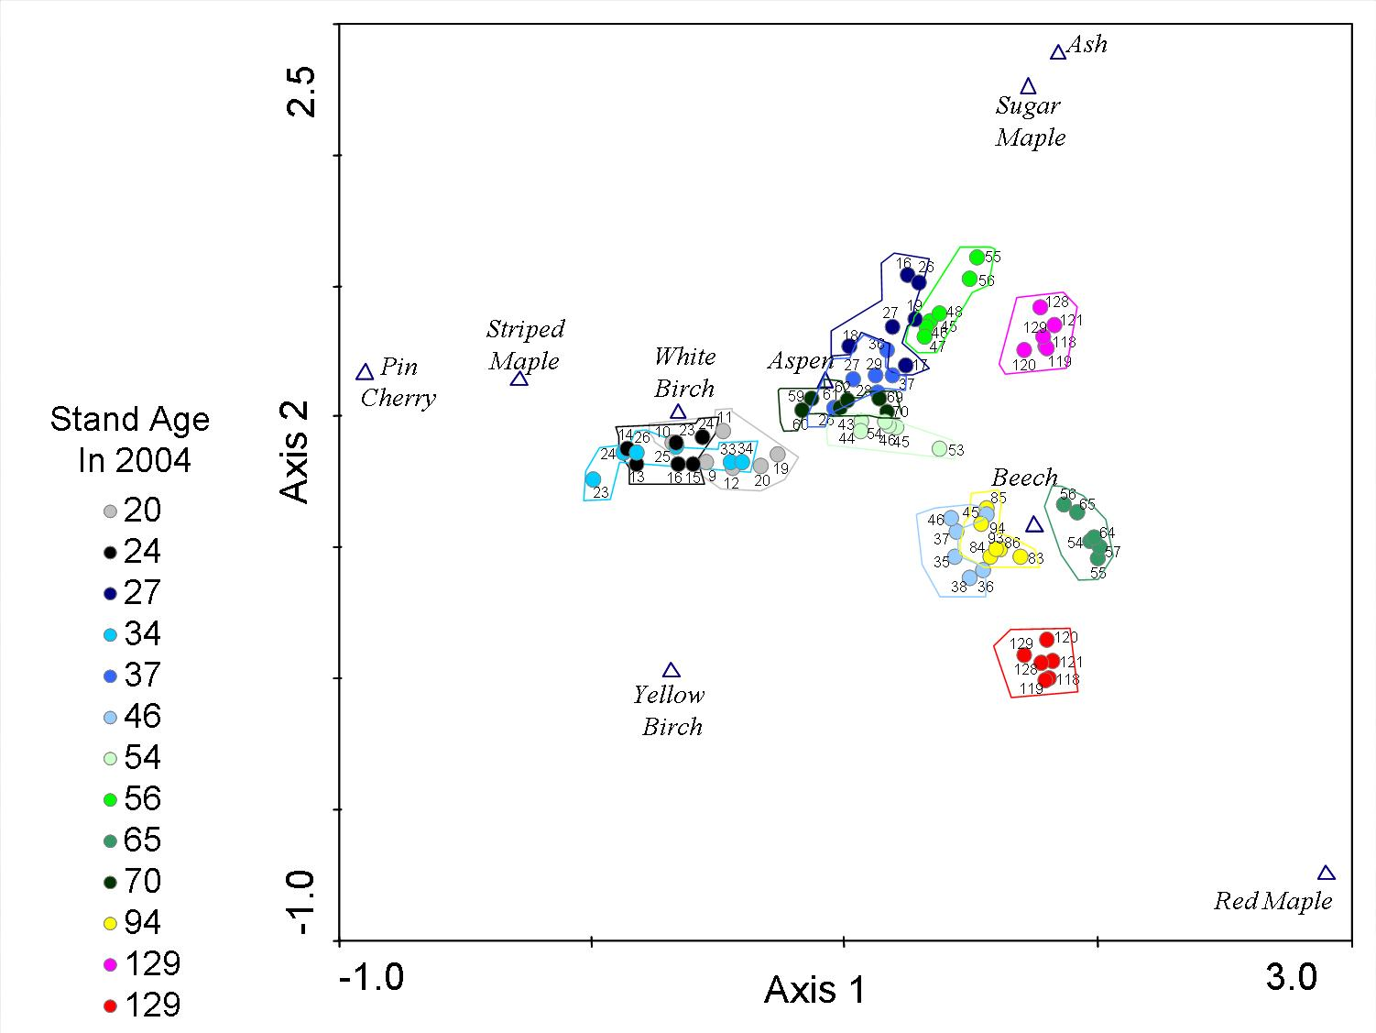

Figure 5. Observed litterfall mass (average of 1994, 1995, and 1996) in thirteen stands compared to foliar biomass estimated by allometric equations (Whittaker et al. 1974, Hocker and Early 1983) using stand inventory data collected in 1994 and 1995.

Figure 6. Species composition of litter in the thirteen stands based on the observed masses in the litter baskets ("O") averaged for 1994, 1995 and 1996 and the predicted mass ("P") based on allometric equations (Whittaker et al. 1974) applied to stand inventory from 1994-1995.

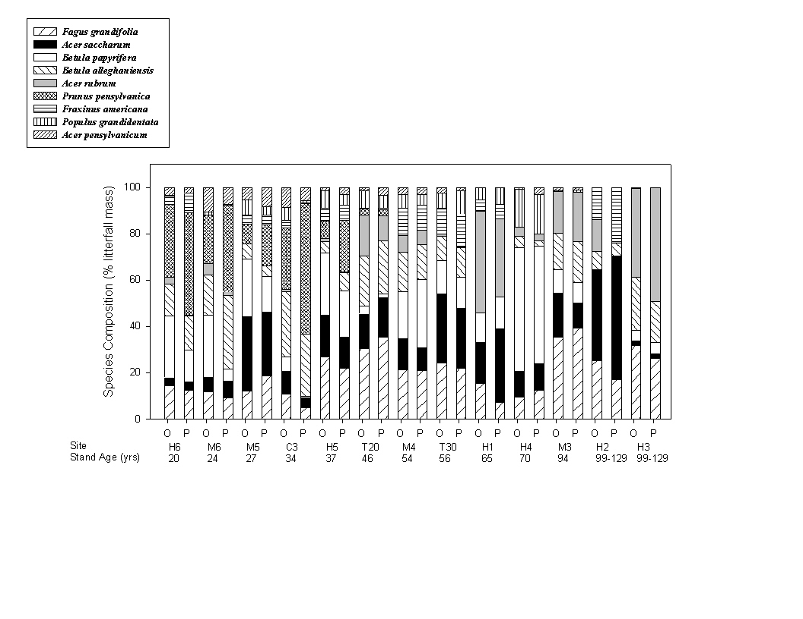

Figure 7. Nutrient concentrations in leaf litter, by species, averaged over years and sites. I think we decided not to include these. The information is presented in Table 2.

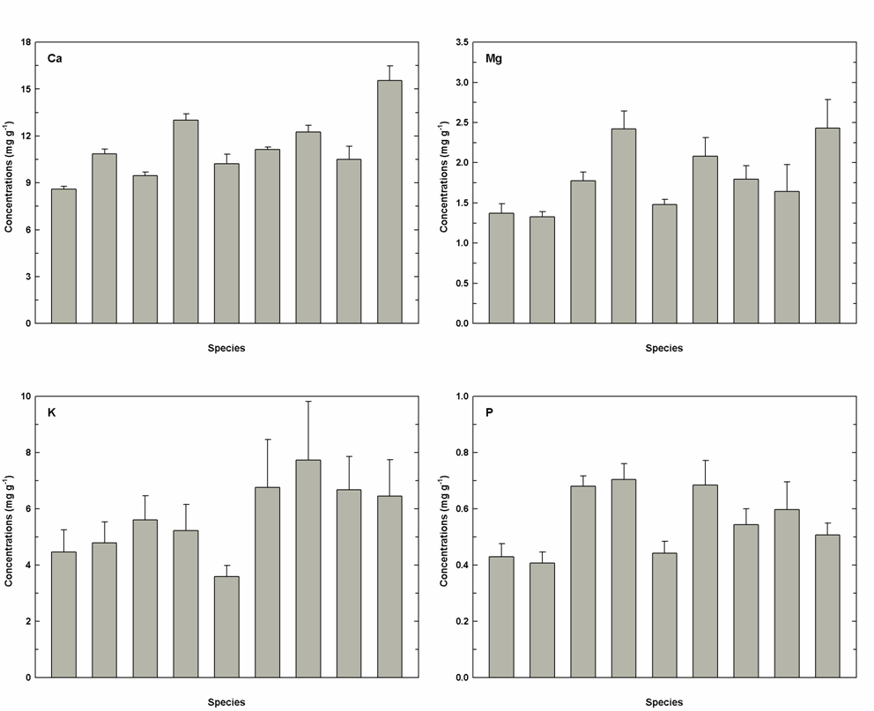

Figure 8. Coefficients of variation in nutrient concentration of litterfall by species over time (5 collection years from 1994 to 2004). Standard errors are for up to13 stands (not all species appear in all stands). (a) Ca. (b) Mg, (c) K, (d) P.

Figure 9. Coefficients of variation for nutrient concentrations in litterfall by species across 13 sites, averaged over years. Standard errors are for n= 3-6 years, depending on the species. (a) Ca. (b) Mg, (c) K, (d) P.

Figure 10. Coefficients of variation in nutrient contents of litterfall by species over time (5 collection years from 1994 to 2004). Standard errors are for up to13 stands (not all species appear in all stands). (a) Ca. (b) Mg, (c) K, (d) P.

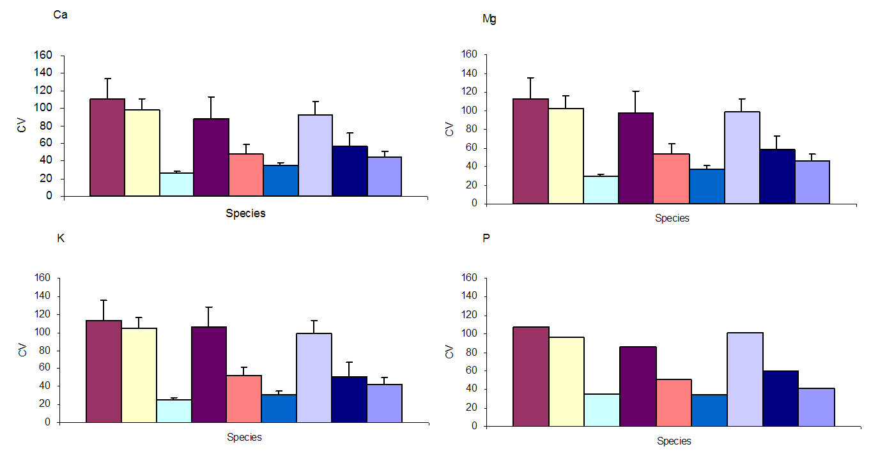

Figure 11. Coefficients of variation for nutrient content of litterfall across 13 sites, averaged over years. Standard errors are for n= 3-6 years, depending on the species. (a) Ca. (b) Mg, (c) K, (d) P.

