Summary of Leedy’s roseroot experimental reintroduction at Watkin’s Glen State Park
and implementation of a demonstration garden at Sonnenberg Gardens
and Mansion State Historic Park

Rachael Renzi
Edna Bailey Sussman Fellowship Recipient, 2022
SUNY College of Environmental Science and Forestry
Introduction
Rhodiola integrifolia ssp. Leedyi (Leedy’s roseroot) is a remarkable rare plant that is known to grow at seven locations in North America. Leedy’s roseroot is listed as G5T1, meaning the taxon is critically imperiled, occurring in very few populations worldwide (NYNHP 2022). In the state of New York, the plant is listed as an S1, which is usually reserved for plants with five or fewer sites. The largest population grows along the cliffs of Seneca Lake. A second, smaller population is located nearby, and a third, historic location grew in Watkin’s Glen State Park. The next closest populations grow on maderate cliffs in Minnesota, and one population grows on metamorphosed granite 7000 feet above sea level in South Dakota. The disjunct nature limits gene flow to within populations. Thus, having large populations is beneficial for upkeep of genetic diversity. However, the populations have been relatively stagnant over the past 20 years, avoiding growth as well as public recognition.
The threats of increased summer droughts and warmer winters will likely have negative impacts on the survival of Leedy’s roseroot. Among the recommendations for enabling delisting of the threatened Leedy’s roseroot by the US Fish and Wildlife Service’s Five-year Review, is the protection of extant populations (USFWS 2021). However, most of the plants in New York State occur on privately owned land. Reintroducing Leedy’s roseroot to Watkin’s Glen State Park will allow for a protected population of Leedy’s roseroot in New York State that can be studied and managed for years to come. An additional demonstration population at Sonnenberg Gardens and Mansion State Historic Park, under the care of the Plant Materials Program, will place Leedy’s roseroot into the public eye. Educating the public on this rare plant opens doors for those outside of the research and natural resources management network to interact with their fascinating local flora.
Completed Work
I grew 96 immature and juvenile Leedy’s roseroot plants in the Illick Hall research greenhouse at SUNY-ESF for planting in Watkin’s Glen State Park. Before planting, soil was shaken from the plant roots, then wrapped in burlap and kept moist until planting (Fig 1.) Three different experimental locations were chosen based on habitat characteristics such as the presence of an active seep, light exposure, substrate type, and accessibility to the public. On May 11, 2022, the New York State Parks scaling team assisted in transplanting the Leedy’s roseroot to their new dwellings in the cliffs. I monitored the plants’ survivorship monthly with binoculars and a final count of plants was done by examining photos taken by the scaling team in September. At the end of the growing season, all three sites had surviving plants, despite enduring a moderate drought (NIDIS 2022).

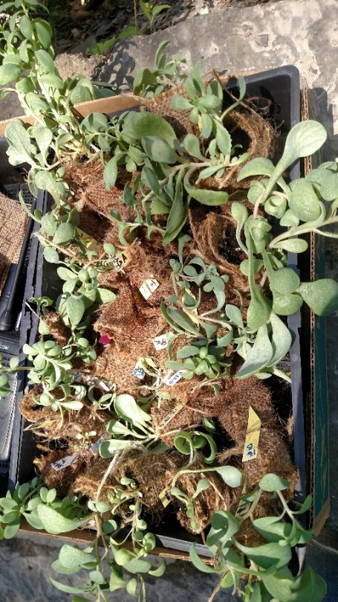
Figure 1. Leedy's roseroot plants wrapped in burlap, ready to be placed into the cliffs at Watkin's Glen State Park.

At Sonnenberg Gardens and Mansion State Historic Park, I worked with Brigitte Wierzbicki and Colton Ratey to establish a garden location for Leedy’s roseroot to grow. We placed the larger plants in a raised bed, protected by wire fencing (Fig. 2). The mature plants were easy to care for in the raised beds, making them ideal plants for a demonstration garden. The smaller immature plants were placed into a subterranean greenhouse where humidity was consistently high. For the transition of the plants into the colder months, we mulched the larger plants and kept the immature plants inside, rather than risk their desiccation from freezing temperatures. In the following spring, we plan to plant the Leedy’s roseroot plants outside with an informational sign, in view of visitors.

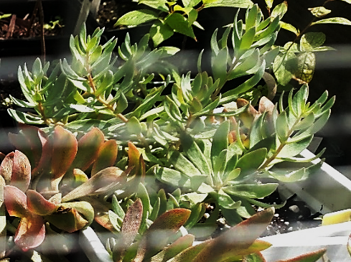
Figure 2. A Leedy’s roseroot plant in an outdoor enclosure at Sonnenberg Gardens and Mansion State Historic Park.

I also had the opportunity to assist with field searches for rare plants at Taughannock State Park, Buttermilk Falls State Park, and Robert H. Treman State Park with guidance from Kyle Webster. I aided in the addition of new census information on locally uncommon plants such as Paronychia canadensis and Lespedesza violacea to the State Park rare plant database. This provided me with an opportunity to broaden my focus from one rare plant to many more locally rare plants. In addition, I was able to broaden my connections with professionals in the field and learn about the positions that may be available to me post-graduation.
Acknowledgements
I am grateful for the opportunity that the E. B. Sussman foundation provided for me to assist in conserving the rare flora of New York State. I am also thankful for the opportunity to interact with professionals in the field through New York Office of Parks, Recreation, and Historic Preservation: Brigitte Wierzbicki, Colton Ratey, Kyle Webster, and the fabulous intern Paige. Additionally, I could not have monitored the plants at Watkin’s Glen State Park without help from the SUNY-ESF undergraduate assistant Tomas Todisco, who spent hours counting plants through small [discount department store] binoculars. Finally, I would not have been able to complete this project without academic guidance from my advisors, Dr. Danilo Fernando, and Dr. Donald Leopold.
Afterword
On the day of the Leedy’s roseroot planting, members of the scaling crew of the Seneca Tribe stepped forward to offer a prayer for the health and survival of the plants. Until this event, my reasoning for reintroducing the plant was centered on combatting its rarity. But there we were, about to send these greenhouse-pampered green babies into the real world, thanking the plants for their existence and wishing them a long life in the park. The immediate impact of sharing this moment was realized as a moment of unity. And a moment of realization for myself: that what we are doing matters – not just for the plant, but for the people who love where they live. The involvement of others is not just for funding and pleasantries. It is for the benefit and connection of all parties involved. This interaction was proof that conservation work enriches our connection to nature, both intellectually and personally.

References:
NIDIS Schuyler County Conditions [WWW Document], n.d. . Drought.gov. URL https://www.drought.gov/states/new-york/county/schuyler (accessed 9.15.22).
New York Natural Heritage Program (NYNHP). 2022. Online Conservation Guide for Rhodiola integrifolia ssp. leedyi. Available from: https://guides.nynhp.org/leedys-roseroot/ Accessed September 25, 2022.
U.S. Fish and Wildlife Service. 2021. Leedy’s roseroot (Rhodiola integrifolia ssp. leedyi) 5-year Review. Bloomington, Minnesota.

