Patterns of change and ecological drivers in the pine barrens forests of Long Island, NY.
Proposal by Joanna Lumbsden-Pinto
SUNY College of Environmental Science and Forestry
Final Report to the Edna Bailey Sussman Foundation, 2020

Introduction

The Long Island Central Pine Barrens (LICPB) represents a unique ecosystem embedded in some of the most urbanized landscapes in the US-- Long Island and adjacent New York City. A diverse mosaic of pitch pine and oak forests, coastal ponds, marshes, grasslands, and streams, LICPB overlies Long Island’s freshwater aquifers and helps to purify drinking water. LICPB depends on periodic fires for its renewal and it is a good example of other pine barrens ecosystems in the Northeastern US (U.S. Geological Survey). Fire is needed to release nutrients, trigger germination of seedlings and eliminate competing species, increase food availability, and provide spaces for a diversity of wildlife to inhabit those areas (Forman & Boerner, 1981; Dovciak et al., 2013; Lee et al., 2018).
Despite its importance, LICPB is currently threatened by catastrophic wildfires due to fuel accumulation as forests become denser following decades of fire suppression (Olsvig et al., 1979; Jordan et al., 2003). When fire suppression occurs, the leaf litter and fallen trees become fuel making the forest liable to ignite and cause irreversible or long-term damage to the forest and human properties, ca. $8.6 billion/year in direct property loss in the US (NESEC. n.d; Hiers et al., 2020). Unfortunately, wildfires and forest regeneration failure are expected to increase as the regional climate becomes warmer and drier due to climate change and urban heat island effects associated with urban sprawl (Brown & Johnstone, 2012; Fairman et al., 2018; Stevens‐Rumann et al., 2018). At present, the complex relationships between fire, forest structure, and climate in the LICPB and other fire dependent ecosystems remain poorly understood due to a scarcity of detailed historical information (Marschall et al., 2016). Paying closest attention to both, fire history and patterns of climate on small areas (microclimate) and the relationship among these two, could contribute to determine vegetation dynamics in the LICPB and inform management, conservation, and restoration strategies for this rare ecosystem.
Summary of Proposed Work

a. Resurvey 42 forest health monitoring plots and quantify vegetation changes across the Long Island Central Pine Barrens (LICPB) since the first survey done in 2005-2006.
b. Monitor microclimate across the LICPB (using temperature sensing iButtons) to understand how the forest cover affects local and regional air temperature and how climate may in turn affect the ability of pine barrens forest to maintain themselves in the context of warming climate.

Work Completed
We were able to survey the remaining 42 Forest Health Monitoring plots and establish 10 new plots in burned areas across the LICPB (Figure 1). I planned the field work, organized the data entry process, trained, and supervised the field interns, and worked in the field while making sure all field interns comply with COVID-19 guidelines. During half summer there were three teams of two, two dedicated to completing the surveys and one to find or locate the plots and mark them for the other two teams. The last part of the summer was mostly dedicated to completing the surveys and data entry which was accomplished by a team of two interns and myself. In the beginning of the summer, I managed to work on my own after the field survey to prepare the climate sensors setting and place them in 38 plots across the LICPB (Figure 2). Below there is a summary of the steps we followed on the data collection:
- Find the plots, locate witness tree, and take photos of the plot
- List all flora & fauna encountered in the plot
- Estimate cover and average height by strata
- Note micro-topography, slope, and aspect
- Mark and set up starting points of the 10 line transects
- Take point cover, litter, and duff depth
- Set up 4 belt transects
- Count all seedlings and saplings, record presence of deer browsing
- Measure trees, downed wood, and count dwarf pine genets (if applicable)
- Enter data on Google sheets to transfer them later to Database

For the microclimate monitoring, I followed the following steps:
- Locate the plots (a subset of 38 plots according to forest type, see Table 1)
- Place 2 sets of 2 iButtons per stake/plot, one set at 1 m and another set at 0.5 m from the ground (Figure 5)
- Leave iButtons in the field for a period of 2 months (from mid-July to mid-September)
- Collect iButtons and stakes from the field at the end of the summer
- Download the data from the climate sensors

Table 1. Climate sensors locations
Forest Type | Number of plots sampled | 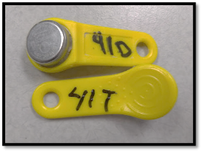
Coastal Oak | 9
Oak-Pine | 11
Pine-Oak | 8
Pitch Pine-Scrub Oak (SO) | 10
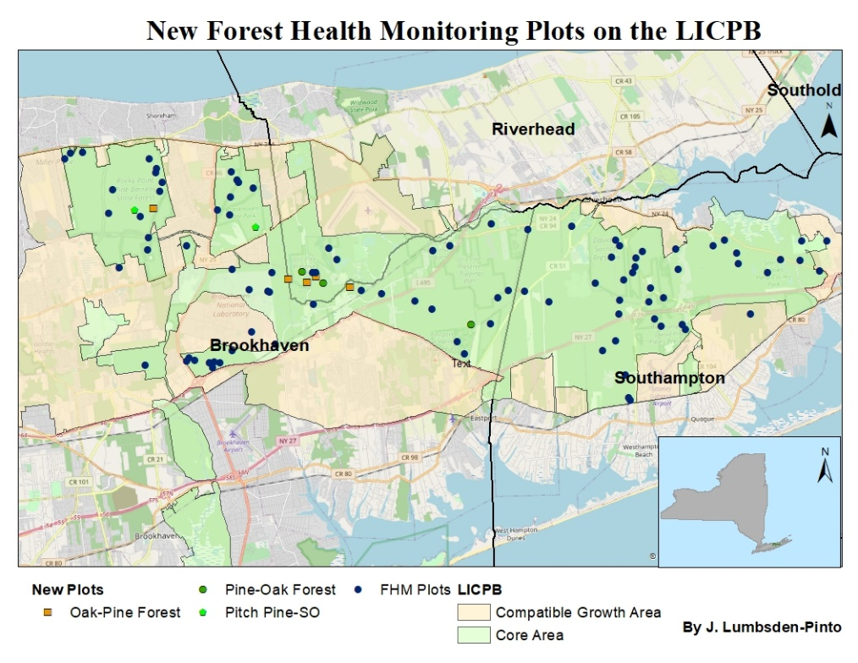

Figure 1. New Forest Health Monitoring plots established in burned areas across the LICPB.

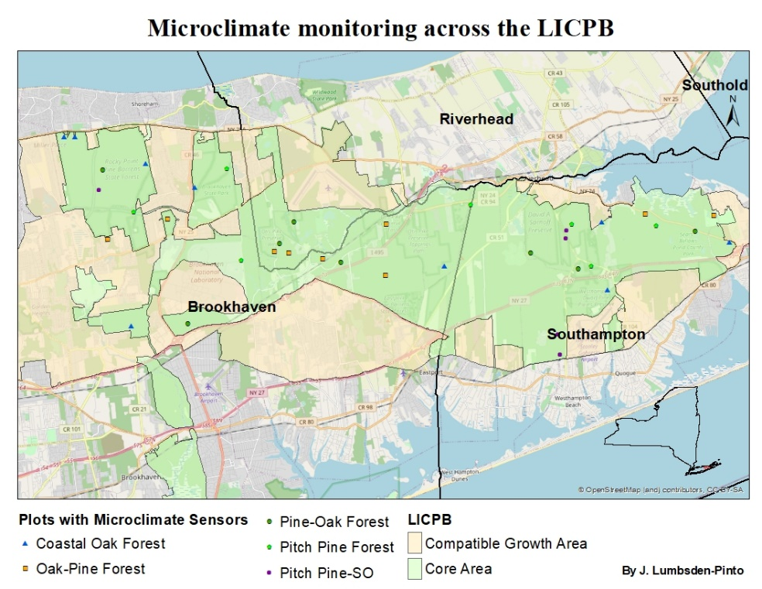

Figure 2. Plots with climate sensors across the LICPB.

Results
Firstly, the preliminary results indicate that the average temperature recorded with the iButtons across the LICPB from the months of July to September was 21.6 °C (70.9 °F). This result is closely the same as the average recorded by the weather station at Brookhaven National Laboratory (BNL Meteorological Services) 21.7 °C (71.1 °F). The records from BNL were taken from the sensors located 2 meters above the ground, one meter higher than the sensors examined in this study (Table 2).
Table 2. Average temperature recorded across the forest types
Forest Type | Temperature (°C)
Coastal Oak | 21.87465301
Oak-Pine | 21.77796022
Pine-Oak | 21.34657254
Pitch Pine-Scrub Oak (SO) | 21.28934131

Secondly, after graphing the average mean values by forest types we observed a minimal difference between the highest and lowest average temperatures (0.6 °C); Coastal Oak and Oak-Pine forests showing the highest values and Pine-Oak and Pitch Pine- Scrub Oak showing the lowest temperature. When comparing these values with canopy cover (%) in those forests we observe the same trend. Coastal oak and Oak-Pine forests have the highest canopy cover and Pine-Oak and Pitch Pine-Scrub Oak are characterized for being more open. This result is unexpected, since we would expect that more canopy cover would lead to lower temperature in the understory and that the more open forests would be warmer, but this is not what these initial results show. A possible explanation for this could be that pine dominated forests generally have an evident layer of shrubs between 2-5 meters tall and this might provide a fresher microclimate meaning lower temperatures near the ground.
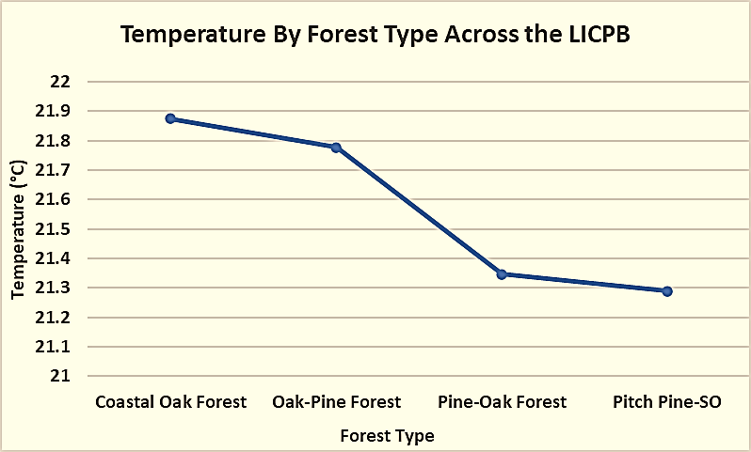
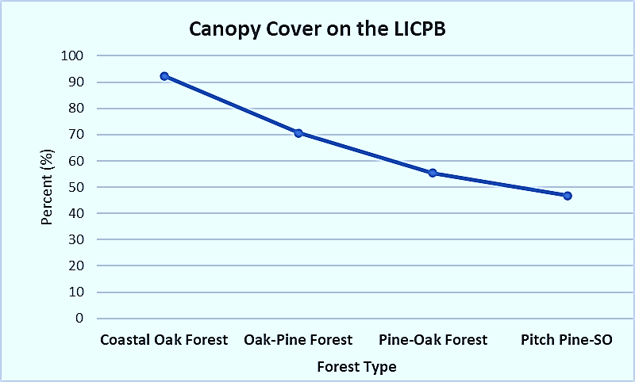
Figure 3. Avg temperature recorded from sensors Figure 4. Canopy cover percentage

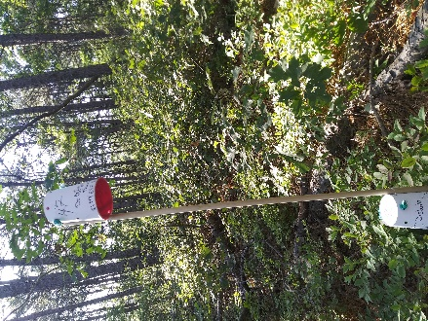
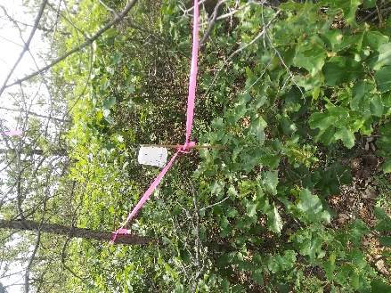
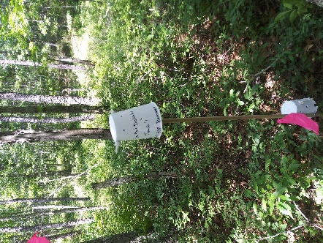
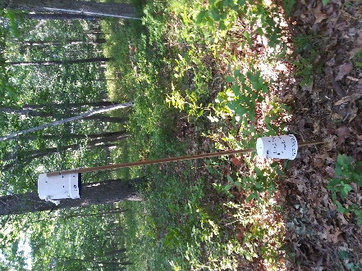

d. Pitch Pine-Scrub Oak

c. Pine-Oak
b. Oak-Pine
a. Coastal oak

Figure 5. Climate sensors across the four Forest Types

Future Work
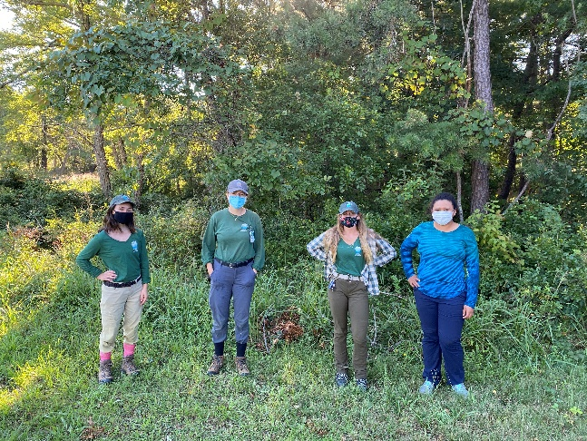
It is important to mention that due to the global pandemic (COVD-19) there were a variety of challenges added to other unknowns we may normally face when doing fieldwork. For example, late start of the data collection (in July as supposed to early June), adjustment to physical distance, wearing masks in the field, and make recurrent breaks to hand sanitize and disinfect the instruments. We also had to stop the field work for several days due to COVID-19 concerns so this and adjusting to new field work logistic contributed to finish much later than originally planned (in early November as supposed to late August). Under these conditions data analysis is still in process. Photo to the right: me (far right) and the three female interns who helped on this work.
The results shown in this report are preliminary and will continue to develop as part of my doctoral dissertation. Perhaps the most important accomplishment of this summer is that we were able to finish the data collection successfully (a work done last year with 8 interns) in midst of a global pandemic.
Acknowledgements
I would like to thank the Edna Bailey Sussman Foundation and Board members for their generous support which helped make this project possible. I express gratitude to my advisor, Dr. Martin Dovciak for kindly supporting and encouraging me throughout the completion of the summer work in these unprecedented times. I also want to extend my deepest gratitude to the Central Pine Barrens Commission represented by Polly Weigand and Shaun Ziegler for supporting this project in various ways and to the interns who helped in collecting and entering the data. I would also like to thank Brookhaven National Laboratory especially Tim Green and Kathy Schwager who supported on the execution of this project. Lastly, I would like to thank Suffolk County for their assistance in providing accommodation and to The New York State Department of Environmental Conservation represented by John Wernet for being helpful in providing access to their land.
Literature Cited
Dovciak M, Osborne PA, Patrick DA, Gibbs JP (2013) Conservation potential of prescribed fire for maintaining habitats and populations of an endangered rattlesnake Sistrurus c. catenatus. Endang Species Res 22:51-60. https://doi.org/10.3354/esr00529
Brookhaven National Laboratory Meteorological Services. Retrieved from https://www.bnl.gov/weather/
Brown, C.D. & Johnstone, J.F. 2012. Once burned, twice shy: Repeat fires reduce seed availability and alter substrate constraints on Picea mariana regeneration, Forest Ecology and Management, Volume 266, 2012. p. 34-41. doi:10.1016/j.foreco.2011.11.006.
Fairman, T. A., Bennett, L.T., & Nitschke, C.R. 2018. “Short-Interval Wildfires Increase Likelihood of Resprouting Failure in Fire-Tolerant Trees.” Journal of Environmental Management, vol. 231, 2019, pp. 59–65., doi:10.1016/j.jenvman.2018.10.021.
Forman, R. T. T. (Editor). 1979. Pine Barrens: Ecosystem and Landscape. 601 pages. Academic Press Inc., Publishers, 111 Fifth Avenue, New York 10003
Hiers, John & O'Brien, Joseph & Varner, J. & Butler, Bret & Dickinson, Matthew & Furman, James & Gallagher, Michael & Godwin, David & Goodrick, Scott & Hood, Sharon & Hudak, Andrew & Kobziar, Leda & Linn, Rodman & Loudermilk, Louise & Mccaffrey, Sarah & Robertson, Kevin & Rowell, Eric & Skowronski, Nicholas & Watts, Adam & Yedinak, Kara. (2020). Prescribed fire science: the case for a refined research agenda. Fire Ecology. 16. 10.1186/s42408-020-0070-8.
Jordan, M. J., Patterson, W. A., & Windisch, A. G. (2003). Conceptual ecological models for the Long Island pitch pine barrens: Implications for managing rare plant communities. Forest Ecology and Management, 185(1-2), 151-168. doi:10.1016/s0378-1127(03)00252-4
Lee, C., Robinson, G. R., Robinson, I. P., & Lee, H. (2018). Regeneration of pitch pine (Pinus rigida) stands inhibited by fire suppression in Albany Pine Bush Preserve, New York. Journal of Forestry Research, 30(1), 233-242. doi:10.1007/s11676-018-0644-3
Marschall, J., Stambaugh, M., Jones, B., Guyette, R., Brose, P., & Dey, D. (2016). Fire Regimes of Remnant Pitch Pine Communities in the Ridge and Valley Region of Central Pennsylvania, USA. Forests, 7(12), 224. MDPI AG. Retrieved from http://dx.doi.org/10.3390/f7100224
Northeast States Emergency Consortium (NESEC). n.d. History of Fires in the Northeast. http://nesec.org.
Olsvig, Linda S., Cryan, J.F. & Whittaker, R.H. 1979. Vegetational Gradients of the Pine Plains and Barrens of Long Island, New York. Chapter 15 from Pine Barrens:Ecosystem and Landscape edited by Forman, R.TT. 1979.
Stevens‐Rumann, C.S., Kemp, K.B., Higuera, P.E., Harvey, B.J., Rother, M.T., Donato, D.C., Morgan, P. and Veblen, T.T. (2018), Evidence for declining forest resilience to wildfires under climate change. Ecol Lett, 21: 243-252. doi:10.1111/ele.12889
U.S. Geological Survey (USGS). n.d. State of the Aquifer, Long Island, New York by New York Water Science Center. www.usgs.gov

