Novel Insight into the Range Expansion and Parasitoid Associates of the Asian Chestnut Gall Wasp in North America

Christopher Johnston
SUNY College of Environmental Science and Forestry
Final Report to the Edna Sussman Bailey Sussman Foundation, 2022

Introduction
The Asian chestnut gall wasp (Dryocosmus kuriphilus, hereafter ACGW) is a specialist gall former considered to be one of the most important pests of chestnut trees around the world (Moriya et al. 1989, Brussino et al. 2002, EPPO 2005, Aebi et al. 2006). Native to China, this invasive species was first detected in North America in 1974 (Payne et al. 1976). ACGW induce damaging galls on nearly all species in the genus Castanea, including the American chestnut, Castanea dentata (Rieske 2007). Current-season gall formation is characterized by the formation of pliable, red to green, globular galls on early season growth (EPPO 2005). Such galls can be found along the stalk to the leaf midvein and cause reduction in shoot elongation, photosynthetic leaf area, flowering, fruiting, and nut production (Cooper and Rieske 2007). Following end of season leaf abscission, galls that develop along the stalk and leaf petioles remain affixed to the tree, gradually turning brown and lignified (Cooper and Rieske 2007). These previous-season galls further reduce host fitness through the elimination of subsequent shoot production while also increasing pathogen susceptibility, most notably in virulent strands of the chestnut blight, Cryphonectria parasitica (Meyer et al. 2015).
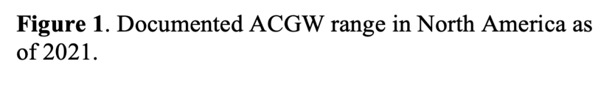
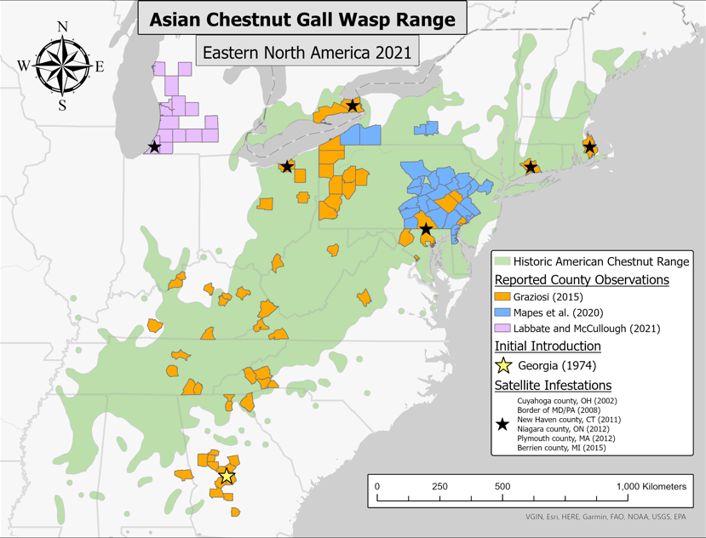
Since its discovery in the state of Georgia, ACGW have been documented throughout much of the historic American chestnut range (Rieske 2007, Graziosi 2015, Mapes et al. 2020). Initial range expansion was characterized by natural wind dispersal that gradually moved northeasterly along the Appalachian mountains (Rieske 2007). This was until 2002, when the first satellite infestation was detected in northern Ohio following the accidental movement of infested plant material (Rieske 2007). Multiple satellite infestations have since been reported throughout this range, with populations occurring as far north as Ontario, New York, and Massachusetts (Graziosi 2015). Additionally, a recent study by Labbate and McCullough (2022) reported ACGW presence outside of the American chestnut range in the state of Michigan; the leading producer of commercially grown chestnuts in North America (Fig. 1).
Currently the most effective method of reducing ACGW damage is through introduction of the biological control agent Torymus sinensis (Matošević et al. 2017). This specialist parasitoid wasp was released in Georgia in 1977 and although initially successful in reducing ACGW infestations, it is unclear how this species has spread and persisted over both time and space (Payne 1978). It is known that T. sinensis has been extremely successful in other parts of the world, reducing ACGW populations below tolerable levels and in some cases nearly eliminating them (Moriya et al. 1989, Ferracini et al. 2019). This is in part due to its acute synchronization with the life cycle of its host (Quacchia et al. 2014). Like ACGW, T. sinensis is univoltine, producing one generation of offspring per year. T. sinensis adults emerge just before gall formation, ultimately laying their eggs into newly developed galls and parasitoidizing ACGW larvae.
In addition to T. sinensis, ACGW has accumulated native parasitoids of oak gall-formers. Of these native parasitoids, Ormyrus labotus has been the most frequently reported. Recently discovered as a species complex rather than a single species, O. labotus is reported to be the most common parasitoid of ACGW in forested areas, while T. sinensis is most common in orchard or suburban settings (Cooper and Rieske 2011, Sheikh et al. 2022). In areas where these parasitoids coexist, Rieske (2014) reports an antagonistic relationship due to differences in voltinism. Unlike ACGW and T. sinensis, O. labotus is multivoltine, producing multiple generations per year. Adults from late-season broods have been observed to lay their eggs into galls following ACGW emergence in which O. labotus parasitoidizes developing T. sinensis larvae. Other native parasitoids found in chestnut galls include Sycophilia mellea, Eupelmus vesicularis, Pteromalus sp., and Pnigalio minio (Rieske 2014). Although these native parasitoids may also negatively affect T. sinensis populations, all such species have only been reported at scarce densities and likely do not have a significant impact on ACGW populations.
While ACGW has been present in North America for nearly 50 years, little is known about the species compared to Asia and Europe. Since 2014, only 2 peer reviewed studies have been published regarding ACGW (Mapes et al. 2020, Labbate and McCullough 2022). Additionally, what is known about this species and its parasitoid associates is primarily based on studies performed in its more southern range (Cooper and Rieske 2007, 2009, 2010, Graziosi and Rieske 2012, 2014). With reintroduction of a blight-tolerant American chestnut throughout the entirety of its historic range imminent, it is important that ACGW research fully encapsulate this range. Not only may galling impact the remnant American chestnut population, a key proponent of restoration plans to increase future genetic diversity, but previous research has found galling to cause tree mortality most frequently in younger individuals, like those set to be planted in our future forests (Moriya et al. 2003). The theme of my Sussman research is thus to add to the current knowledge of ACGW and its parasitoid associates in North America.

Objectives
The primary objectives for this project were to 1) discover previously undocumented infestations using the citizen science database iNaturalist and 2) compare parasitoid population dynamics of long-term and short-term infestations.

Methods
iNaturalist Survey
I used the citizen science database iNaturalist to perform pseudo-surveys of Castanea observations for ACGW. As iNaturalist provides photo attachments for all observations, I searched these photos for presence of ACGW gall formation. In order to validate this method, I first searched all New York Castanea observations. For each observation I first confirmed that the individual was in the genus Castanea through leaf, bud, and/or bark morphology. For correctly identified Castanea observations I then visually searched photos for presence of current-season and/or previous-season gall formation along the shoots, petioles, and leaf midveins. Observations in which I discovered gall formation were then ground-truthed through in-person surveys. Although I was unable to survey some sites due to private property restrictions, all in-person surveys discovered gall formation and thus proved the validity of this method.
I then conducted this method for all North American countries, states, provinces, and territories. New state observations were ground-truthed through in-person surveys and gall collection. In addition to Castanea observations, I validated the 75 ACGW observations (referred to as Oriental chestnut gall wasp on iNaturalist) via gall characteristics and host association. For observations with locational accuracies of 400 meters or less, infestations were recorded at the state, county, and in some cases town level. Such observations were additionally crosschecked using context clues from photos and Google Earth imagery. Observations with accuracies greater than 400 meters were only reported in my total observations unless a location was able to be confirmed with the original iNaturalist observer. Furthermore, I then used this method to search Castanea observations from regions around the world where ACGW has yet to be reported.

Parasitoid Research
To compare long-term and short-term parasitoid population dynamics, I collected ACGW galls from 8 sites ranging from 23 to 2 year infestations. The oldest sites include 23, 14, and 12 year infestations while the newer sites include 4, 3, and 2 year infestations. An additional 2 sites were included that do not have a definitive year of first detection but dispersal estimates predict 10 and 7 year infestations (Rieske 2007). Previous-season galls were collected from an additional 2 sites (18 year infestation at Mantua, OH and 7 year infestation at State College, PA) but did not have high enough current-season gall formation to be included in the rest of the study. All sites were similar ecotypes with high chestnut density and nearby oak populations. Sites occurred at different points along the ACGW invasion front ranging from southern Virginia to northern New York (Fig. 2).
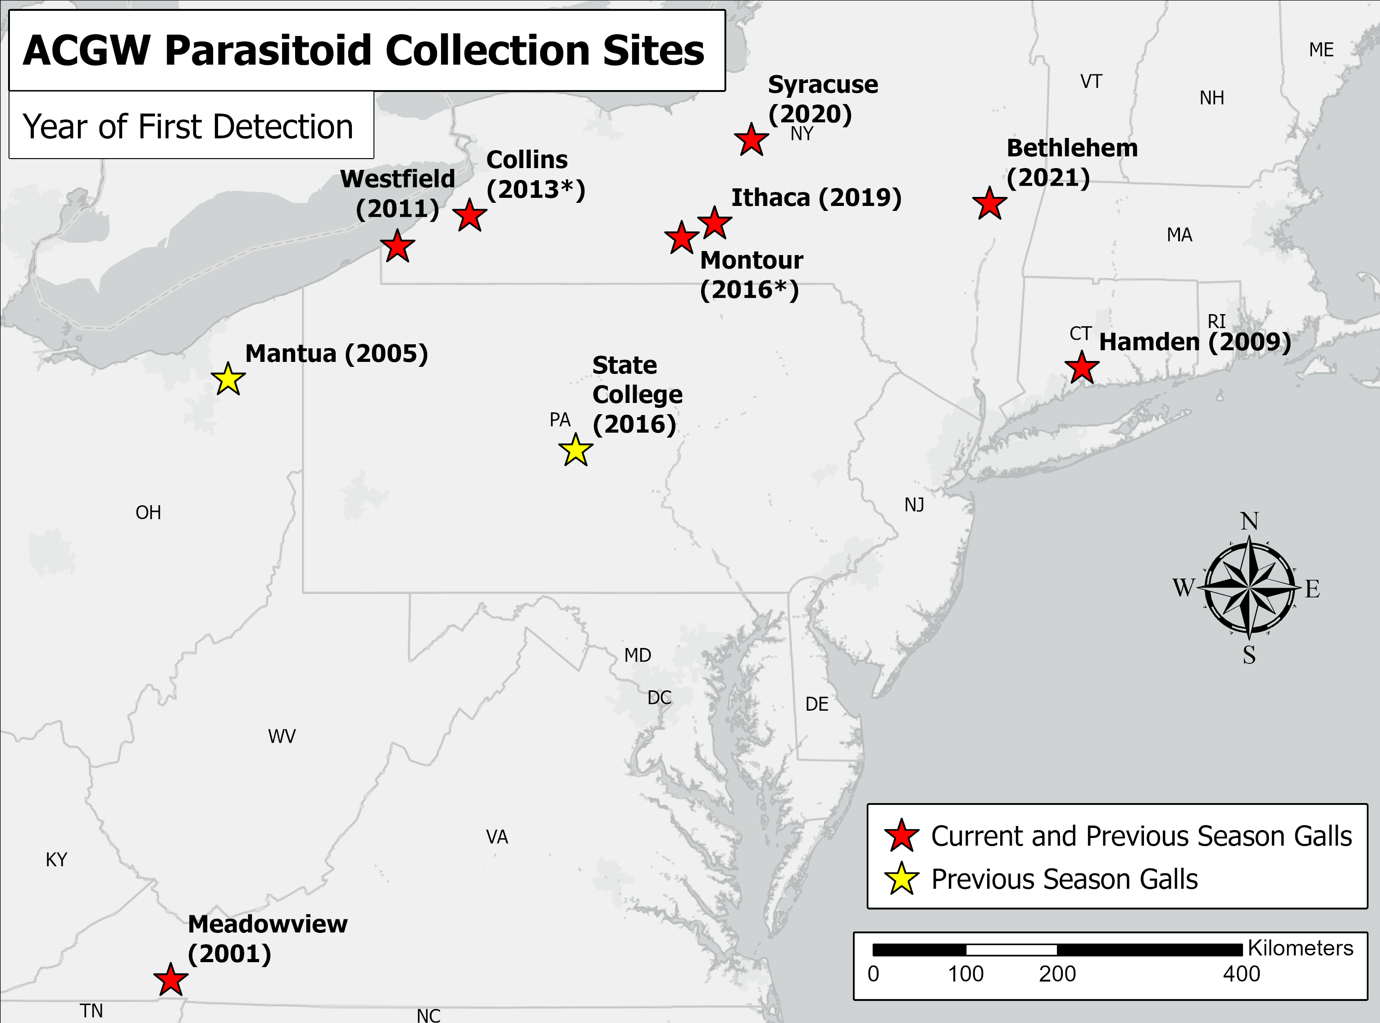
Figure 2. Collection sites and year of first detection for study on ACGW parasitoid associates. Asterisks following years indicate estimated arrival based on dispersal estimates of 25 km/yr from nearest known ACGW detection.
In order to standardize collection times among sites, we used growing degree days with a base of 50º F (GDD_{50F}) provided by two online databases, GreenCast Syngenta and Climate Smart Farming at Cornell University. Four collections were made at each site including one collection of previous-season galls before the chestnut growing season and three collections of current-season galls throughout the growing season. Previous-season galls are known to contain adult T. sinensis and O. labotus (Cooper and Rieske 2011). Current-season galls are more complex, containing adult ACGW and native parasitoids as well as developing parasitoid larvae (Cooper and Rieske 2011). Growing degree day estimates for each round of gall collections were based off research by Labatte and McCullough (2022) and
can be seen in Table 1.
During each collection we randomly collected 5-20 galls from 5 different trees, with the exception of the newest infestation in Bethlehem, NY where gall formation was restricted to only a few trees. Once we clipped the galls from the trees, we then clipped them again underwater to avoid cavitation and wrapped the stems in wet paper towel before transporting them on ice to our lab at SUNY-ESF. Once in the lab, we clipped the galls an additional time before sticking them in hydrated floral foam. Floral foam bricks were placed in mesh topped containers and kept in the SUNY-ESF insectary for at least 2 weeks. Emergents were removed weekly and stored in 70% ethanol for future identification. We rehydrated the floral foam regularly until galls began to get moldy or desiccate. After this, we removed the galls and froze them at -20º C for future dissection.

Results and Discussion
iNaturalist Survey
A total of 17,614 Castanea observations were searched for ACGW presence (16,260 North American and 1,354 from other ACGW absent regions). In all, 339 observations were found to have gall formation. In North America, 2 new state observations were detected in Missouri and Rhode Island. The observation in Missouri occurred at the Missouri Botanical Gardens in St. Louis and is the first detection of ACGW west of the Mississippi river. The observation in Rhode Island occurred in a forested area in Burrillville, approximately 100 meter south of the CT-MA-RI tri-state marker. Here we were able to observe where ACGW naturally dispersed from CT to RI utilizing remnant American chestnut resprouts.
Furthermore, we report 83 new county observations (Fig. 3). These county detections increase our understanding of how ACGW has dispersed from the satellite infestations reported by Graziosi (2015) while also increasing the clarity of this species dispersal throughout the entire historic American chestnut range. It appears that ACGW has now spread throughout the vast majority of this range, with the edge of the invasion front occuring near central Massachusetts. Lastly from these 339 observations, locational accuracy was precise enough to report 135 towns or cities where ACGW is or has been present. Such observations are helpful in understanding and predicting small scale dispersal patterns.

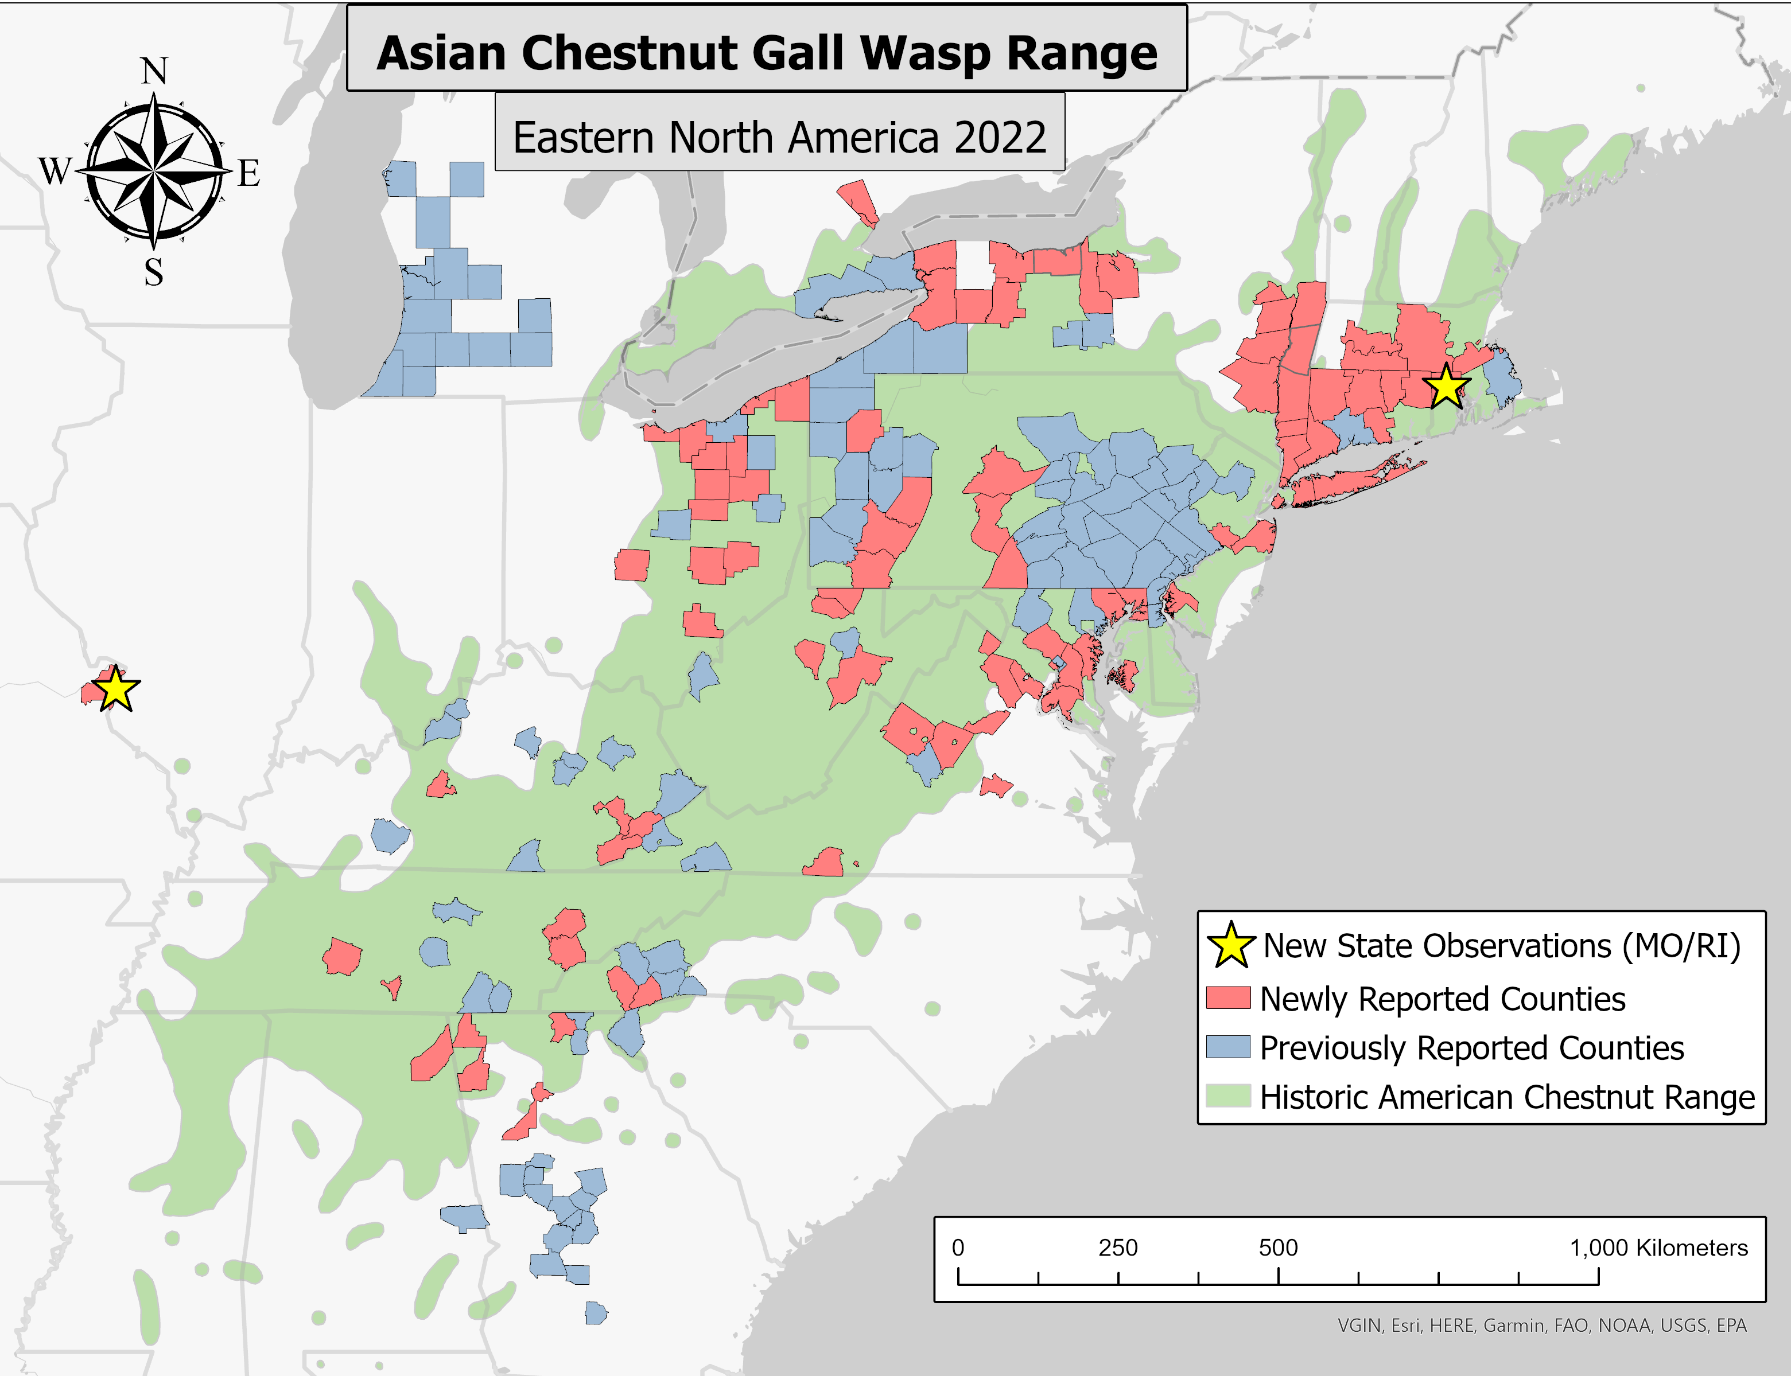
Figure 3. Detected ACGW range expansion in North America with the use of iNaturalist.

Of the 1,346 observations from other parts of the world where ACGW had not been reported, we found 3 with definitive gall formation. The first occurs in Copenhagen, Denmark where a 2013 national survey was conducted concluding ACGW to be absent (EPPO 2022). Like North America, ACGW is the only cynipid gall former to be reported in the western palearctic region. In this observation from May 2022, only current-season gall formation can be distinguished. It is unclear if this infestation occurred through natural dispersal from neighboring ACGW present countries or a possible satellite introduction (Fig. 4a).
Gall formation can also be observed in two observations from Taiwan and Yunnan, China. In Taiwan an observation from May 2020 shows previous-season gall formation. In Yunnan an observation from October 2019 shows current and previous-season galls. Although native to the area, ACGW has yet to be reported in either of these regions (Fig. 4b).
Gall formation in the eastern palearctic is more complicated than other parts of the world due to the discovery of two species, Dryocosmus zhuili and Synergus castaneus. D. zhuili, described by Zhu et al. (2015), is the second gall forming cynipid wasp to be discovered to definitively induce gall formation on Castanea hosts. Gall morphology by ACGW and D. zhuili are indistinguishable and can only be differentiated through adult morphology. Currently, D. zhuili has only been reported on Castanea henryi but may be able to induce gall formation on other Castanea species. Photo attachments from both observations do not provide enough evidence to determine whether the host is C. mollissima or C. henryi. Furthermore, S. castaneus is a recently discovered cynipid wasp that may induce gall formation on Castanea. Members in the tribe Syrnergini are believed to be inquilines, residing in developed galls rather than inducing them. In a study by Bernardo et al. (2013), researchers report S. castaneus emergence from Castanea galls in which a known gall former was not detected. It is thus possible S. castaneus may induce gall formation on Castanea hosts, however it has yet to be tested directly.
(A)
(B)
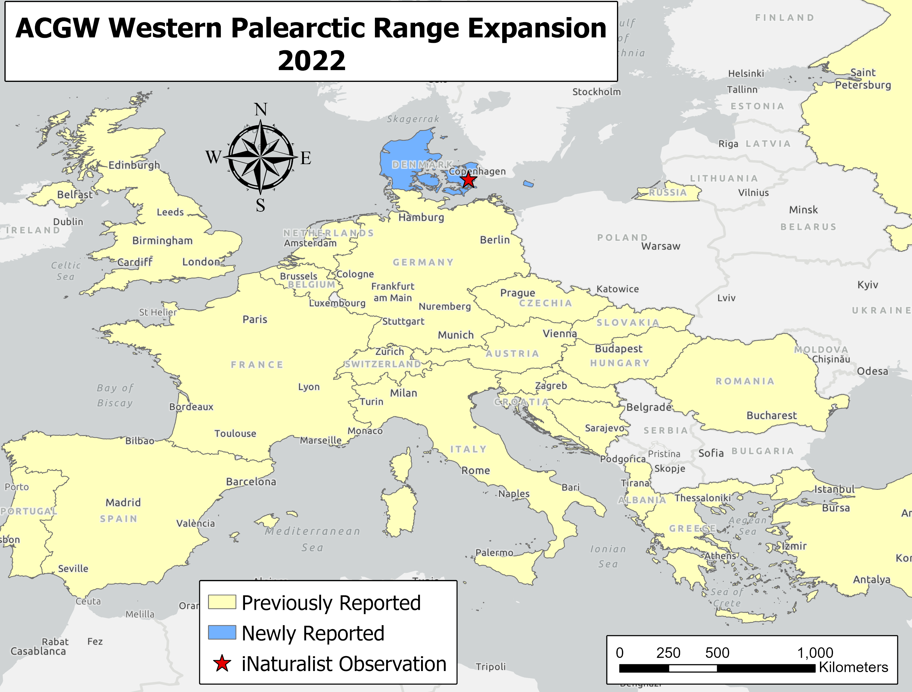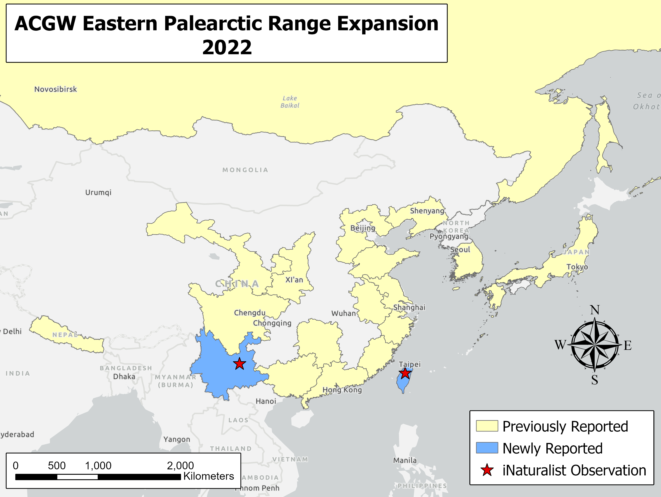
Figure 4. (A) ACGW detection in Denmark. (B) Potential ACGW detections in Taiwan and Yunnan, China.
Preliminary Results and Future Work

Preliminary Results and Future Work
Parasitoid Research
Due to the travel time required for this study, gall dissection and species identification is still ongoing. Preliminary results indicate that the biological control, T. sinensis, is not ubiquitous throughout the current range of ACGW. T. sinensis emergence from previous-season galls was witnessed in older infestations but not among newer infestations in this study (Fig. 5). Further species identification is needed to determine the native parasitoid diversity that emerged from current-season galls. Additionally, PCR analysis will be conducted on the third round of current-season gall collections to test for T. sinensis and O. labotus presence that may have been absent due to variability in emergence times among sites.

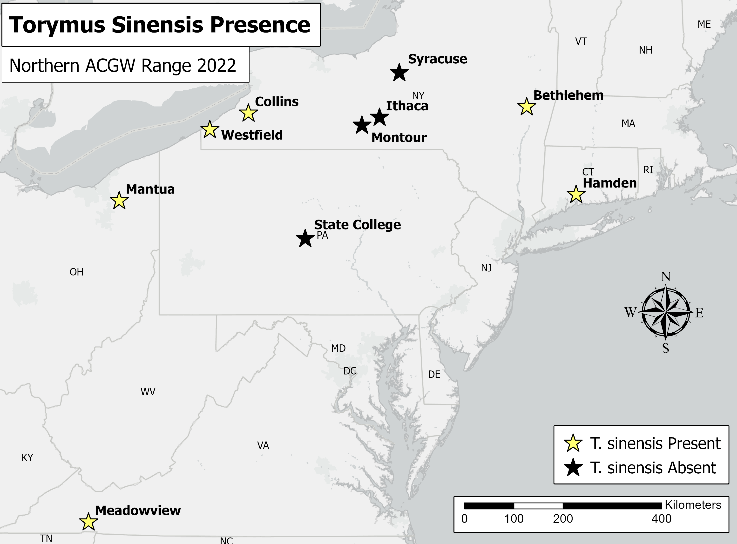
Figure 5. Presence or absence of Torymus sinensis at collection sites.
Conclusions
This study revealed a drastic range expansion of ACGW throughout the historic American chestnut range. Although previous research noted significant dispersal through isolated introduction events, further range expansion and connectedness of these populations was poorly understood. Our results provide clarity to this, alluding to a connected population throughout nearly the entirety of the American chestnut range. This reveals the prevalence of ACGW throughout our current landscape and highlights the need for increased research on how to manage it. We will add to this field of research with the results from our temporal study of ACGW parasitoid populations. Preliminary results show persistence and prevalence of the biological control agent T. sinensis among older infestations but indicate absence of the species in newer infestations. This provides evidence to a potentially impactful lag time between the dispersal of ACGW and its biological control. Our results will provide useful information for organizations tasked with initial plantings of transgenic American chestnut saplings. On a broader scale, we were able to demonstrate a cost-efficient method of invasive species monitoring through the use of citizen science. As plant-insect interactions are typically highly specialized, this method may be useful for other invasive insects with species-specific damage.

Acknowledgements
I would like to first and foremost thank the Edna Bailey Sussman Foundation for their generous funding. I would like to additionally extend my appreciation to my major professor, Dr. Dylan Parry, for his insight and support. Furthermore I am grateful to my steering committee members, Dr. Andrew Newhouse and Dr. Lynne Rieske-Kinney, as well as my host supervisor, Sara Fitzsimmons of the American Chestnut Foundation, for their input and advice throughout this process. Lastly, a special thanks to all the members of the Parry and Powell lab at SUNY-ESF for their willing aid and supportive nature.

References
Aebi, A., K. Schönrogge, G. Melika, A. Alma, G. Bosio, A. Quacchia, L. Picciau, Y. Abe, S. Moriya, K. Yara, G. Seljak, and G. N. Stone. 2006. Parasitoid Recruitment to the Globally Invasive Chestnut Gall Wasp Dryocosmus kuriphilus. Pages 103–121 in K. Ozaki, J. Yukawa, T. Ohgushi, and P. W. Price, editors. Galling Arthropods and Their Associates. Springer Japan, Tokyo.
Bernardo, U., M. Gebiola, Z. Xiao, C.-D. Zhu, J. Pujade-Villar, and G. Viggiani. 2013. Description of Synergus castaneus n. sp. (Hymenoptera: Cynipidae: Synergini) Associated with an Unknown Gall on Castanea spp.(Fagaceae) in China. Annals of the Entomological Society of America 106:437–446.
Brussino, G., G. Bosio, M. Baudino, R. Giordano, F. Ramello, and G. Melika. 2002. A dangerous exotic insect threating European chestnut. L’Inf. Agr. 37:59–61.
Cooper, W. R., and L. K. Rieske. 2007. Community Associates of an Exotic Gallmaker, Dryocosmus kuriphilus (Hymenoptera: Cynipidae), in Eastern North America. Annals of the Entomological Society of America 100:236–244.
Cooper, W. R., and L. K. Rieske. 2009. Woody Stem Galls Interact With Foliage to Affect Community Associations. Environmental Entomology 38:417–424.
Cooper, W. R., and L. K. Rieske. 2010. Gall structure affects ecological associations of Dryocosmus kuriphilus (Hymenoptera: Cynipidae). Environmental Entomology 39:787– 797.
Cooper, W. R., and L. K. Rieske. 2011. A native and an introduced parasitoid utilize an exotic gall-maker host. BioControl 56:725–734.
EPPO. 2005. Dryocosmus kuriphilus. EPPO Bulletin 35:422–424.
EPPO, 2022. EPPO Global database. In: EPPO Global database, Paris, France: EPPO. 1 pp. https://gd.eppo.int/
Ferracini, C., E. Ferrari, M. Pontini, M. A. Saladini, and A. Alma. 2019. Effectiveness of Torymus sinensis: a successful long-term control of the Asian chestnut gall wasp in Italy. Journal of Pest Science 92:353–359.
Graziosi, I. 2015. INVASIVENESS OF AN EXOTIC GALL WASP IS INFLUENCED BY INTERACTIONS WITH EXOTIC AND ENDEMIC ORGANISMS. Theses and Dissertations—Entomology. 15.
Graziosi, I., and L. Rieske. 2012. Local spread of an exotic invader: using remote sensing and spatial analysis to document proliferation of the invasive Asian chestnut gall wasp. iForest - Biogeosciences and Forestry 5:255–261.
Graziosi, I., and L. K. Rieske. 2014. Potential Fecundity of a Highly Invasive Gall Maker, Dryocosmus kuriphilus (Hymenoptera: Cynipidae). Environmental Entomology 43:1053–1058.
Labbate, L., and D. G. McCullough. 2022. Phenology, Density and Parasitism of Asian Chestnut Gall Wasp (Dryocosmus kuriphilus) (Hymenoptera: Cynipidae) in Recently Invaded Chestnut (Castanea spp.) Orchards in Michigan. Environmental Entomology 51:747–762.
Mapes, C. C., G. P. Setliff, R. S. Courtney, and K. Bothur. 2020. Range Expansion and Dispersal of the Asian Chestnut Gall Wasp Dryocosmus kuriphilus Yasumatsu (Hymenoptera: Cynipidae) in the Mid-Atlantic States. Transactions of the American Entomological Society 146:503–519.
Matošević, D., N. Lacković, K. Kos, E. Kriston, G. Melika, M. Rot, and M. Pernek. 2017. Success of classical biocontrol agent Torymus sinensis within its expanding range in Europe. Journal of Applied Entomology 141:758–767.
Meyer, J. B., L. Gallien, and S. Prospero. 2015. Interaction between two invasive organisms on the European chestnut: does the chestnut blight fungus benefit from the presence of the gall wasp? FEMS Microbiology Ecology 91:122.
Moriya, S., K. Inoue, A. Otake, M. Shiga, and M. Mabuchi. 1989. Decline of the Chestnut Gall Wasp Population, Dryocosmus kuriphilus YASUMATSU (Hymenoptera : Cynipidae) after the Establishment of Torymus sinensis KAMIJO (Hymenoptera : Torymidae). Applied Entomology and Zoology 24:231–233.
Moriya, S., M. Shiga, and I. Adachi. 2003. Classical biological control of the chestnut gall wasp in Japan. Pages 407-415 in Proceedings of the 1st international symposium on biological control arthropods. USDA Forest Service, Washington.
Payne, J. A., R. A. Green, and D. D. Lester. 1976. New nut pest: an oriental chestnut gall wasp in North America. Annual Report of the Northern Nut Growers Association 67:83–86.
Payne J.A. 1978. Oriental chestnut gall wasp: New nut pest in North America. Pages 86–88 in Proceedings, American Chestnut Symposium. West Virginia University Press, Morgantown, WV, US.
Quacchia, A., S. Moriya, R. Askew, and K. Schönrogge. 2014. TORYMUS SINENSIS: BIOLOGY, HOST RANGE AND HYBRIDIZATION. Acta Horticulturae:105–111.
Rieske, L. K. 2007. Success of an exotic gallmaker, Dryocosmus kuriphilus, on chestnut in the USA: a historical account. EPPO Bulletin 37:172–174.
Rieske, L. K., C. C. Rhoades, and S. P. Miller. 2003. Foliar Chemistry and Gypsy Moth, Lymantria dispar (L.), Herbivory on Pure American Chestnut, Castanea dentata (Fam: Fagaceae), and a Disease-Resistant Hybrid. Environmental Entomology 32:359–365.
Rieske, L. K. 2014. Accumulation of Natural Enemies by the Asian Chestnut Gall Wasp in North America. Acta Horticulturae:205–209.
Sheikh, S. I., A. K. G. Ward, Y. M. Zhang, C. K. Davis, L. Zhang, S. P. Egan, and A. A. Forbes. 2022. Ormyrus labotus (Hymenoptera: Ormyridae): Another Generalist That Should not be a Generalist is not a Generalist. Insect Systematics and Diversity 6:8.
Zhu, D.-H., Z. Liu, P.-F. Lu, X.-H. Yang, C.-Y. Su, and P. Liu. 2015. New Gall Wasp Species Attacking Chestnut Trees: Dryocosmus zhuili n. sp. (Hymenoptera: Cynipidae) on Castanea henryi from Southeastern China. Journal of Insect Science 15.

