Fall and overwintering bat activity in the Outer Cape (Cape Cod), MA.

Submission to the Edna Bailey Sussman Foundation

Sarah-Jayne Collins
State University of New York
College of Environmental Science and Forestry

Background

Bat populations in North America have suffered significant population declines resulting from the rapid spread of White Nose Syndrome (WNS), alongside other anthropogenic stressors. Since the winter of 2006/2007 WNS has been steadily spreading west across the USA and Canada. WNS is caused by a cold-tolerant fungus (Pseudogymnoascus destructans) which grows on the bat wing tissues and membranes during hibernation (Fenton, 2012), resulting in severe damage (Cryan et al. 2010). It irritates the skin and causes the bats to arouse from torpor more regularly and emerge from hibernation too early, resulting in the bats using up fat reserves more quickly and increasing mortality rates (USFWS 2019). This disease has severely impacted populations of bat species that are reliant on underground sites for hibernation, most notably those species belonging to the genus Myotis; including Indiana (Myotis sodalis), northern long eared (Myotis septentrionalis) and little brown bats (Myotis lucifugus). Northern long eared bat populations in the north east are estimated to have declined by up to 99% in some locations (USFWS 2018). In 2015, decline in these species resulted in the listing of the northern long-eared bat as federally threatened under the Endangered Species Act (16 U.S.C. §§ 1531-1544). The US Fish and Wildlife service are also considering future protection for other bat species at risk. The provision of such protection highlighted a knowledge gap and lack of research addressing seasonal habitat use of these “cave” roosting bat (and other) species in the Northeast (Fenton et al. 1992, Miller et al. 2003).

The Outer Cape of Cape Cod, MA, is described as the “forearm” of the peninsula, between Eastham in the South and Provincetown in the north. This area forms the northernmost point of the Atlantic coastal plain, which stretches from Cape Cod National Seashore (CACO) to the Southern tip of Florida. Bats in the Outer Cape are understudied with limited information available on species abundance, habitat associations and roost selection preferences throughout the seasons. Published information on bat species and activity in this specific location is limited to an observational historical study, focusing on identification of migratory species during fall (Miller, 1897). More recent data (unpublished) are available from summer surveys (2015 and 2016) which were carried out within CACO (Curry, 2017 & Fletcher, 2017) along with fall surveys (2017 and 2018), identified the presence of northern long eared bats within the Outer Cape, with detections prior to the hibernation period. This suggests that populations on the coast are not suffering declines of the same magnitude compared to inland populations, despite exposure to the same stressors. Similar results have also been noted in other coastal regions (Martha’s Vineyard and Nantucket) indicating the potential importance of the Northern coastal plain for this, and similar, species (Dowling et al, 2017). In addition, a pilot study conducted during winter 2018/2019, detected Myotis calls on at least 1 occasion each month at 13 of 14 sites monitored. This project, in its entirety, is the first to focus on bat activity throughout fall and winter in this mainland location, testing the hypothesis of year-round residency of Myotis species.

The project goal is to build on previous summer data to better understand seasonal bat habitat use in the Outer Cape and identify features of importance for Myotis species at different times of year (with a specific focus on northern long eared bats). As there is no previous data available on bat species during fall and winter in this area and there are no underground structures that would serve as “traditional” hibernation roosts in this location, this study will take the first step towards identifying fall migration movements and potential “alternative” hibernation sites for Myotis species in the Outer Cape. Combining data from summer, fall and winter will enable land managers and conservation groups to enact more targeted management plans and protection for areas of importance for bat species at risk.

The continued survey effort and data collection in CACO is also helping to increase public knowledge and interest in the local bat populations. In addition to forming long lasting and mutually beneficial relationships with the National Park staff, the ongoing bat research is promoting a general increase in awareness and interest in bats within the National Seashore and surrounding area, with the hope that this will lead to specific management protocols to benefit and protect the resident bat species. This is also opening up discussions of continued efforts and future projects with the National Park Service, including possible citizen science programs and educational events. The data also adds to the wider information pool on the status of threatened Myotis species (as well as general bat species data) and the role of the coastal region in the maintenance and potential recovery of species at risk.

Methods

Study Area

The Outer Cape of Cape Cod is located in Barnstable County, Massachusetts (41˚57’N, 70˚ W). The study area includes CACO (176.5 km² area) along with the townships of Eastham, Wellfleet, Truro and Provincetown, with commercial land, private residences, local conservation areas and Wellfleet Bay Wildlife sanctuary. The Outer Cape is characterized by a variety of terrestrial and marine ecosystems including beaches, salt marshes, kettle ponds, and vernal pools. The forested landscape is dominated by pitch pine and scrub oak forests, but also includes heathlands, dunes, and sandplain grasslands. This is an extremely popular tourist location and is home to some of the most popular beaches in the United States including Nauset Lighthouse Beach, Coast Guard Beach and Marconi beach and historic site.

Study design - Acoustic surveys

Fall surveys were carried out between August and November 2017. In 2017, 47 sites, within the boundary of CACO were surveyed. These were randomly selected from previous summer study locations. During fall 2018 the survey area was extended to encompass the entire Outer Cape (Figure 1). These survey sites were selected using stratified random sampling. Using ArcGIS, a grid of 1km² cells was laid over the entire Outer Cape. Each cell was classified by a majority habitat type (Open, Pitch Pine, Fresh water, mixed woodland, disturbed/developed). The Outer Caper was divided into 4 zones (Eastham, Wellfleet, Truro and Provincetown), with the number of cells selected in each zone proportional to the zones land cover area. In each zone a number units for each habitat type were randomly selected. The method allows for a better geographical selection of sites coving various habitat types and limits clustering.

Within each selected unit, a survey point was identified as a point along a linear feature (road, path, cycle way, woodland edge), closest to the center of the cell. Wildlife acoustic SM3Bat or SM4Bat acoustic detectors were deployed at each survey location, for 3 consecutive nights, on 3 separate occasions (late summer, fall and pre-hibernation), separated by at least 3 weeks. Each acoustic detector was programmed to automatically record bat echolocation within a frequency range designed to capture calls of northeastern bat species (16 kHz to 192 kHz), between sunset and sunrise each night. Microphones were mounted on poles at a standardized height of 2.5m above ground. Each detector was partnered with an Onset Hobo data logger set to record temperature (ºC) and relative humidity (%) at regular intervals at each location.

In addition, a pilot study was carried out during winter 2018/2019 (November – May), with continuous monitoring of 14 sites (Figure 2). The sites were locations selected where from those identified with positive Myotis during the 3rd survey occasion (pre-hibernation) of the fall surveys. Each detector was set up as during the fall surveys: set to record between sunset and sunrise, microphone mounted on a pole at 2.5m and partnered with an Onset Hobo data logger. Equipment was weather proofed and insulated. Batteries were changed and data downloaded every 2 weeks.
Figure 2. Winter pilot study acoustic sampling sites in the Outer Cape

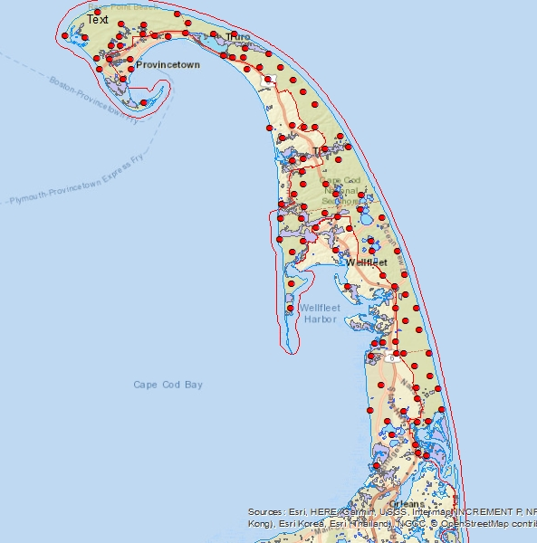
Figure 1. Fall acoustic sampling sites in the Outer Cape

ArcGIS was also used to calculate Euclidean distance from each of the sample sites to landscape features such as water, main roads, and human developments (roads, houses, and buildings).
Acoustic Call classification

Echolocation recordings were automatically classified to species using SonoBat version 4.2.1 software (Arcata, CA, USA), and species codes appended to call files. All files were then manually vetted, based on maximum, minimum, characteristic frequency and call slope to confirm species I.D. and identify files missed by the automated software (O’Farrell et al, 1999). Call files with at least 3 discrete pulses were identified to species where possible. While acoustic monitoring provides a useful survey technique, allowing the collection of more data with minimal resources, it must be viewed with caution as species call structures can overlap significantly and vary depending on habitat type, especially seen with Myotis species. As such, poor quality calls, or where species identification was not possible, recordings were classified to the following groups;
- Myotis - Mylu/Myso/Myle/Mylu (little brown, Indiana, eastern small footed, northern long eared)
- High frequency - Pesu/Labo (Tri-colored, eastern red bat)
- Low frequency - Epfu/Lano/Laci (Big brown, silver haired, Hoary bat)

The acoustic survey data will be modelled using occupancy modelling, in Presence. To allow for habitat use models and avoid biases associated with relative abundance and relative use via number of passes each bat species or group will be assigned detection (1) or non-detection (0) per site/per night regardless of the number of calls recorded.

Results
Fall acoustic surveys
Combined files from fall 2017 and 2018 surveys totaled 79,776 individual recordings of which I manually verified 19,421 identified to species. Eight species were identified during these surveys, including northern long eared, little brown, eastern small footed, tri-colored, big brown, silver haired, hoary and eastern red bats. An additional 19,755 call files were manually identified and assigned to one of the 3 groups (Myotis, High or Low). The totals for each species/group are shown in figure 3 below.

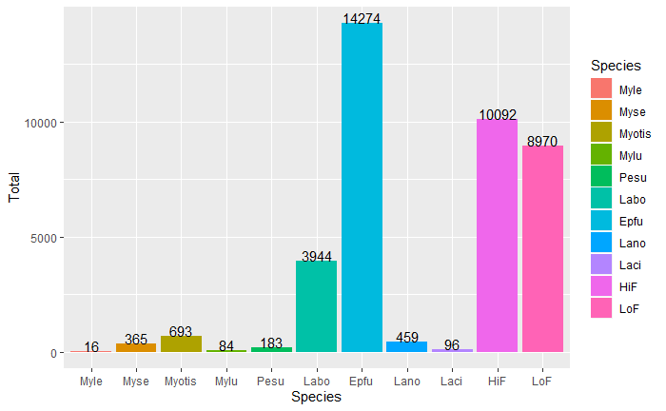
Figure 3: Fall survey acoustic survey results - Species totals

The chart in figure 3 shows that Myotis bats, as a group (unidentified Myotis, Myle, Myse and Mylu) together are the 3rd most commonly recorded bats in the Outer Cape. Within all of the Myotis calls that could be identified to species, northern long eared bats were the most commonly noted in this area.

The three figures below (Figure 4, 5 and 6) display the distribution of all Myotis species calls grouped together during the three distinct survey occasions (late summer, fall and pre-hibernation). As expected, the level of activity decreases moving from summer to winter, with colder temperatures. However, Myotis calls were positively identified late into the season at multiple locations through the Outer Cape.

Figure 4: Myotis species recorded during visit 1 Figure 5: Myotis species recorded during visit 2 Figure 6: Myotis species recorded during visit 3
“Late Summer” “Fall” “Pre-hibernation”

In support of the acoustic data, over 275,000 weather data points were also recorded. These are being analyzed in R to obtain nightly (between sunset and sunrise) and daily (between sunrise and sunset) averages, maximum and minimum for temperature (°C) and relative humidity (%), for each survey location.

Winter acoustic surveys
All eight species were recorded during the 2018/2019 winter pilot study. Myotis species were positively identified at 13 of the 14 sites surveyed. As a group, all Myotis species (Unidentified Myotis, Myle, Myse, Mylu) were the most commonly recorded species group, with a total of 516 calls identified (Figure 7). A large number of the calls were recorded during April (Figure 8), as the average nightly and daily temperature began to increase (Figure 9 and 10). However, at least 1 Myotis call was identified during each month of the survey period (Figure 8).

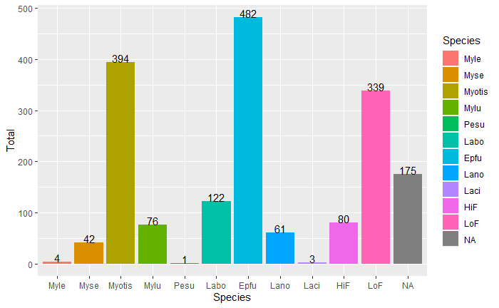
Figure 7: Winter acoustic surveys - species totals

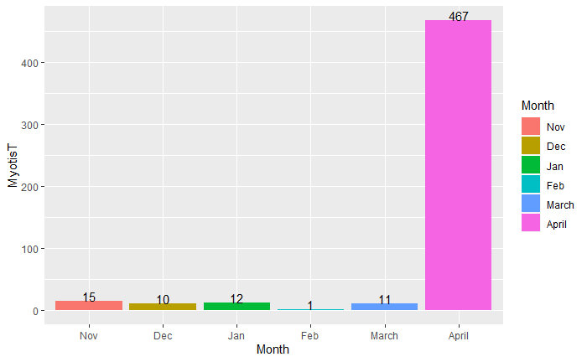
Figure 8: Winter acoustic surveys – Myotis species totals

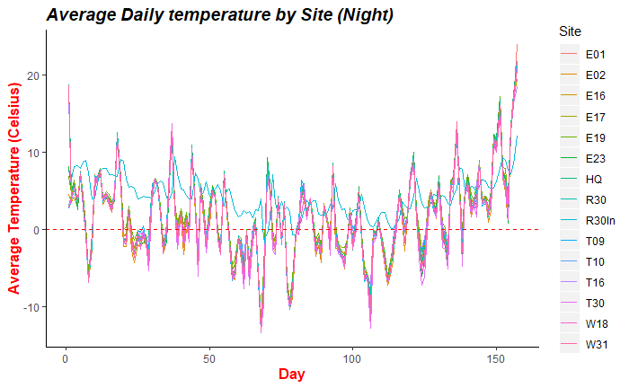
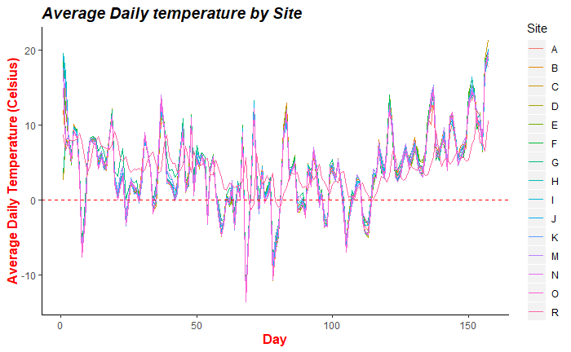

Figure 9: Winter surveys - average daily temperature Figure 10: Winter surveys average nightly per site (Hobo data loggers) temperature per site (Hobo data loggers)

Further Analysis
My objectives for statistical analysis are to determine the relationship of spatial, temporal and environmental factors to the probability of detection (p), and determine how site occupancy (Ψ) varies among landscape covariates for Myotis species as a group and specifically northern long eared bats. I am currently finalizing summary statistics for all of the fall climatic data collected on the Hobo data loggers. This will combine with additional weather data (wind speed and precipitation) gathered from local weather stations. Using this climatic data and landscape metrics (from ArcGIS), I will fit single season occupancy models for each Myotis species individually and also as a group. Each survey night is classed as a single sampling event with a total of 9 repetitions per survey location. Akaike's Information Criteria (AIC) will be used to select the most parsimonious models.

Future Work
Additional winter surveys are proposed for 2019/2020 and 2020/2021, building on the results of the pilot study, with an expanded study design to incorporate more sites. The sites will be randomly selected using the 1km² grid cells and method used for selection of fall survey sites.

Acknowledgements
This research would not have been possible without the financial support of the Edna Bailey Sussman Foundation, the National Park Service and the Nickerson Fellowship (Funding provided by the Friends of Cape Cod National Seashore). The Edna Bailey Sussman Foundation will be recognized in all reports, and publications that result from this research. I would also like to thank Dr. Shannon Farrell my major professor for her all of her support and guidance and members of my thesis committee Dr. Amanda Cheesman and Dr. Vanessa Rojas for their advice and support. I could not have carried out the field work for this project without the help from my field technicians and the invaluable and ongoing guidance and support from Dr. Robert Cook (National Park Service liaison and guide to Cape Cod National Seashore). I also have a special thank you to the staff at CACO, especially the shorebird team, as well as the staff at Wellfleet Bay Wildlife Sanctuary and all members of the public that gave us access to their gardens to do surveys.

References
Average temperature for daytime

Curry, R.B. (2017) Personal communication.

Dowling, Z., Sievert, P.R., Baldwin, E., Johnson, L., Von Oettingen, S. and Reichard, J. (2017) Flight Activity of Offshore Movements of nao-Tagged Bats on Martha’s Vineyard, MA. US Department of the Interior, Bureau of Ocean Energy Management, Office of Renewable Energy Programs, Sterling, Virginia. OCS Study BOEM 2017-054. 39 pp.

Fenton, M.B., L. Acharya, D. Audet, M.B.C Hickey, C. Merriman, M.K. Obrist, D.M. Syme, and B. Adkins. 1992. Phyllostomid bats (Chiroptera: Phyllostomidae) as indicators of habitat disruption in the Neotropics. Biotropica 24:440-446.

Fenton, M. B. 2012. Bats and white-nose syndrome. Proceedings of the National Academy of Sciences 109:6794–6795.

Fletcher, J. (2017) Habitat use and species assemblage of bats in a North East coastal plain ecosystem (Masters dissertation).

Cryan, P. M., C. U. Meteyer, J. G. Boyles, and D. S. Blehert. 2010. Wing pathology of white-nose syndrome in bats suggests life-threatening disruption of physiology. BMC Biology 8:135–135.

Miller, G.S. (1897) Migration of Bats on Cape Cod, Massachusetts. Science: vol. 5, No. 118, pp 541-543.

Miller, D.A., E.B. Arnett, and M.J. Lacki. 2003. Habitat management for forest-roosting bats of North America: a critical review of habitat studies. Wildlife Society Bulletin 31: 30-44.

(USFWS) United States Fish and Wildlife Service. 2019 . Frequently Asked Questions: White-Nose Syndrome. <https://www.whitenosesyndrome.org/faqs>. Accessed 31 October 2019.

(USFWS) United States Fish and Wildlife Service. 2018. Northern Long-Eared Bat Fact Sheet. Northern Long-Eared Bat Fact Sheet. <https://www.fws.gov/midwest/endangered/mammals/nleb/nlebFactSheet.html>. Accessed 10 May 2018.

