Habitat Selection, Prey Preference, and Population Ecology of
Northern Barrens Tiger Beetles in the Hudson Valley, New York

McKenzie Wybron
SUNY College of Environmental Science and Forestry
Final Report to the Edna Bailey Sussman Foundation
2019

Introduction

Northern barrens tiger beetles (Coleoptera: Carabidae) are widely distributed throughout eastern North America dwarf pine-oak barren ecosystems, usually only occurring in small localized populations throughout their entire range (Mawdsley 2005). Populations of this beetle are at risk due to habitat destruction and modification, alteration to the frequency and intensity of disturbance, particularly fire, and over-exploitation by collectors (Schlesinger and Novak 2011).
Although the northern barrens tiger beetle historically was widely distributed, it has been extirpated from six known locations in New York and is currently found at only at a single site in the state (Schlesinger and Novak 2011). In 2004, this single population was discovered in a dwarf pitch pine barren at Sam’s Point Preserve on the Shawangunk Ridge, New York (Schlesinger and Novak 2011). Subsequent observations indicate there are actually two discrete populations, one on each side of Lake Maratanza along the northwest and southeast ridges in the preserve (NYNHP 2017).
Northern barrens tiger beetles are most commonly associated with open sandy or rocky areas within forested habitat. These openings are used for behavioral temperature regulation, foraging, mating, and oviposition. Decades of fire suppression in the Shawangunk mountains has greatly reduced the extent of existing openings and has curtailed regeneration of pitch-pine forests (Schlesinger and Novak 2011, Beers et al. 2011). In the absence of wildfire or prescribed burns, fire intolerant vegetation is spreading and encroaching into the barren openings northern barrens tiger beetle rely on, thereby degrading suitable habitat for the beetles (Mawdsley 2005). Development and implementation of a management plan for northern barrens tiger beetle is necessary for promoting natural openings and native plant assemblages in order for this rare species to persist. The goal of this research was to document basic population ecology and define important habitat and prey variables for this rare northern barrens tiger beetle.

Methods

Individual beetles were marked, released, and recaptured in the summers of 2017, 2018, and 2019 in Sam’s Point Preserve. Adults were captured using an insect net or identified using binoculars from a distance to minimize disturbance to the beetles (Hudgins et al. 2011; Fig. 1). On sunny days, a serpentine pattern was walked from the access point across a delineated area of patchy openings bounded by contiguous pine cover resulting in a near complete assessment of each habitat patch. On cloudy or rainy days, loose rocks were opportunistically lifted to check for hiding beetles encountered during the walk.

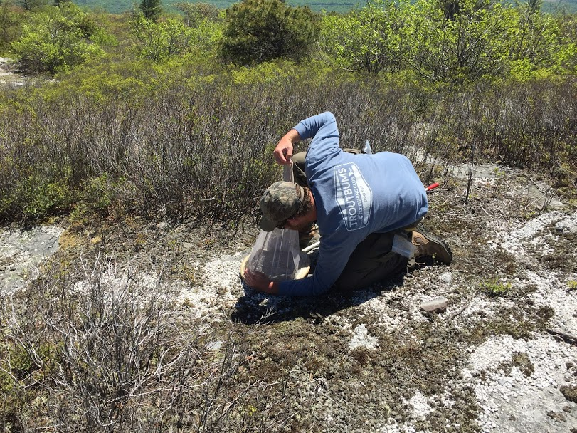
Figure 1. Christian Chevalier (field technician) capturing beetles at Sam’s Point Preserve.

Marks were made from the center of a hole-punched piece of Rite-in-the-Rain® paper cut in half, with numbers written on it. These labels were attached to individual beetles with super glue after the elytra was rubbed with a Q-tip soaked in nail polish remover then lightly scuffed with sandpaper. No marks were lost or faded using this technique (Fig. 2). The marks did not appear to hinder normal adult behavior as beetles were observed successfully foraging and mating with marks present.

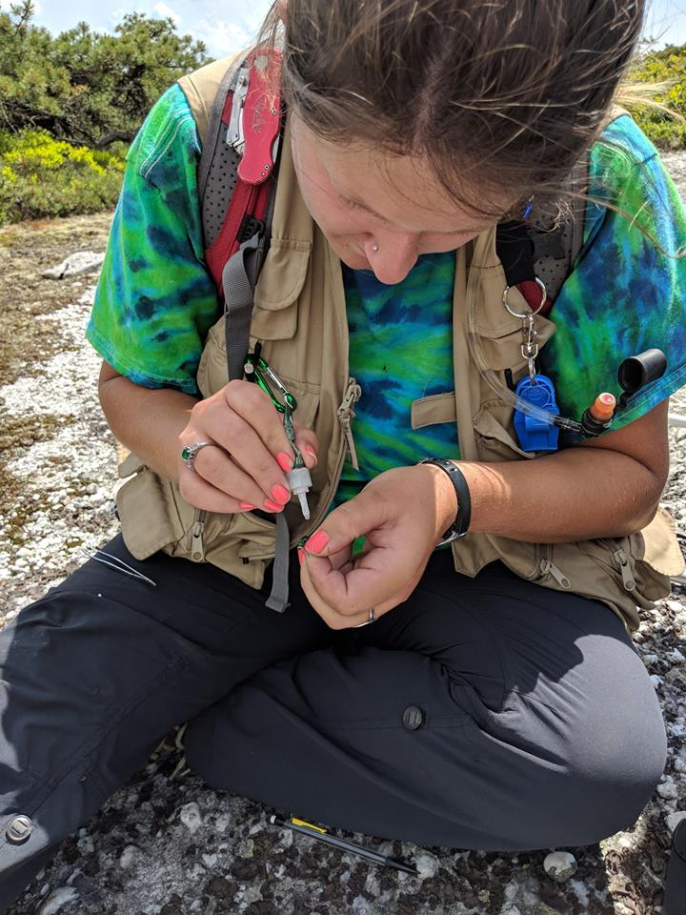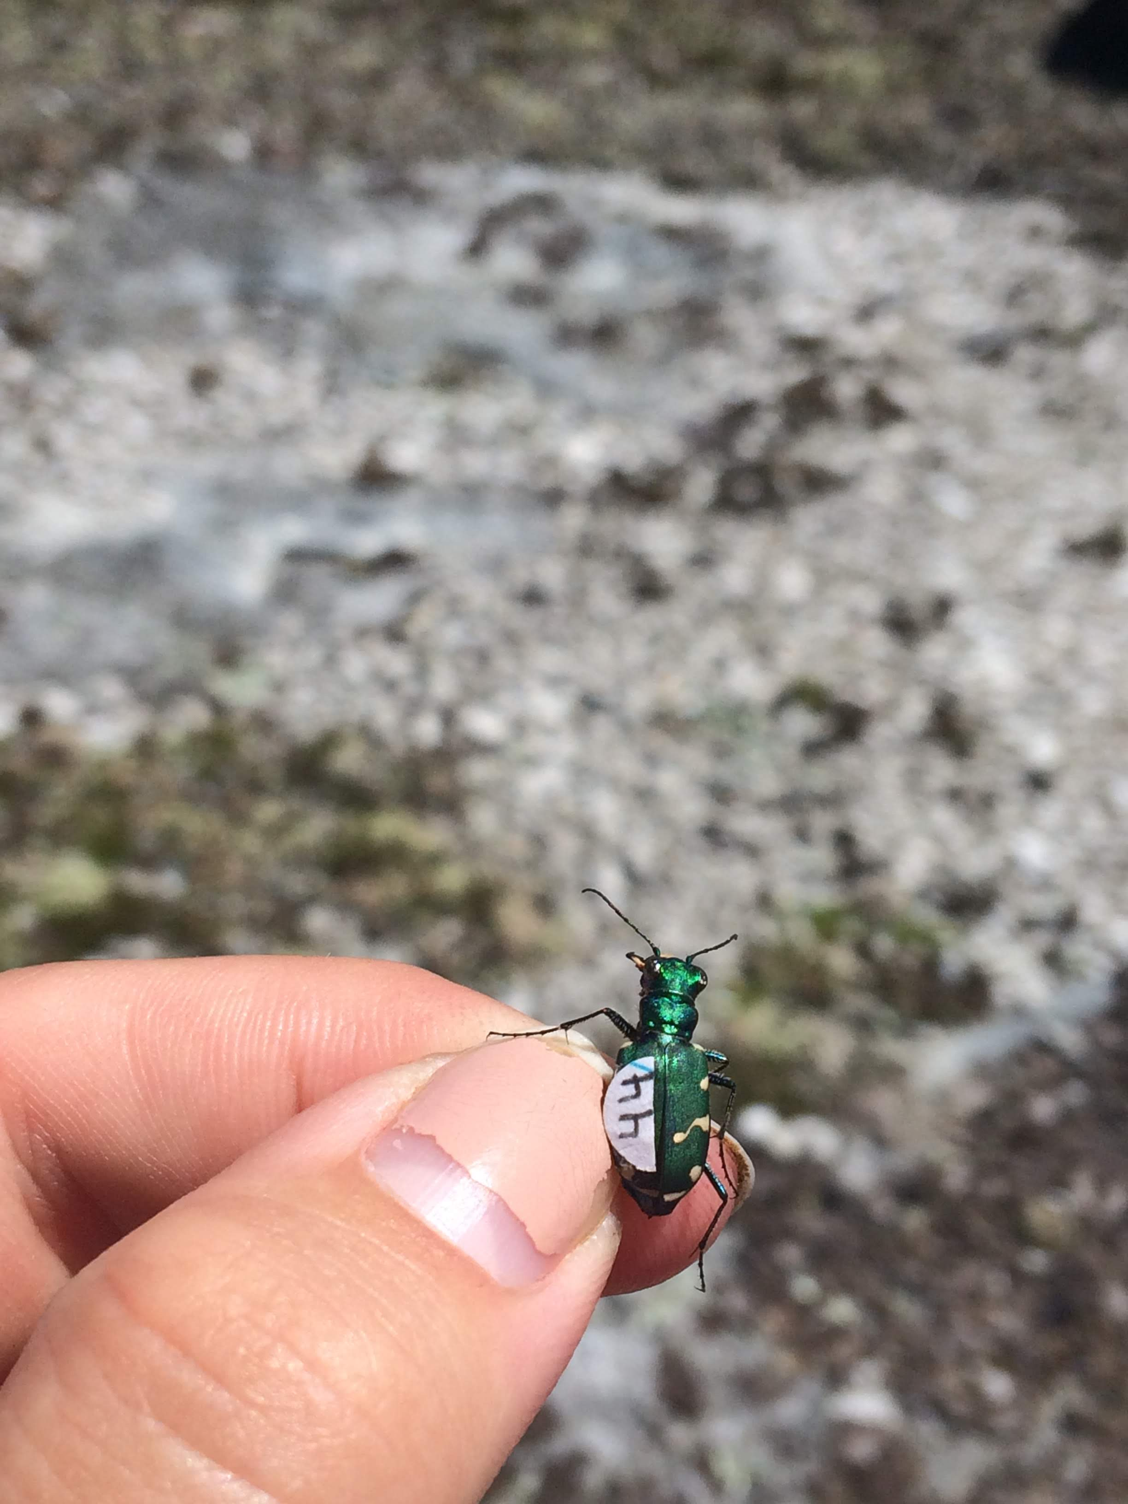
Figure 2. A) M. Wybron marking a northern barrens tiger beetle. B) Tagged tiger beetle.

Mark-recapture data points from a 2017 survey were used to randomly select plots where adult tiger beetles were detected. Each plot was 5-m radius and percent cover of trees, shrubs, forbs, grasses was estimated, all plants were identified, and substrate categorized using the following classification: sand (< 0.4 cm), pebbles (0.4–15 cm), cobbles (> 15 cm), rock slab. There was a total of 51 plots within the preserve where tiger beetles were present. Within the Preserve, 66 plots were randomly established in habitat with no beetles that was qualitatively similar to habitat where beetles were found (presence of dwarf pitch pine, blueberry, huckleberry, and open areas with varying substrate). I also established 17 randomly located plots in visibly similar habitat outside of Sam’s Point Preserve where beetles were not detected. Some of these were in areas encompassing the beetle’s historic range at Hogencamp Mountain.
At each habitat plot, prey abundance counts (ants) were performed in two 1 m² quadrats. The first was placed 1 m from the center in line with a northerly reading and the second 1 m south of the center. Any ant entering the quadrat was recorded for 3 min. Ant densities were low, allowing observers to avoid recounting the same ants. Ants within a quadrat were collected over a 1 min time period using an aspirator and later identified to genus using A Field Guide to the Ants of New England (Ellison et al. 2012). Voucher specimens were deposited in the State University of New York College of Environmental Science and Forestry insect museum in Syracuse, New York. Ant species richness, Shannon Wiener (H’) diversity, and abundance data were used in random forest models to determine their importance and a t-test was used to evaluate if there were significant differences between plots with and without tiger beetles.
Habitat variables and prey abundance and diversity data were put into models for statistical analyses. Model included sites from Sam’s Point Preserve where beetles were detected and sites outside of Sam’s Point Preserve encompassing the known historical range of northern barrens tiger beetles, but where no individuals were detected in this study.

Results

In 2018 and 2019, a total of 169 tiger beetles were captured, with 83 (49.1%) being males and 82 (48.5%) being females (2.4% were unknown due to difficulty in sexing some of the beetles). Mark-recapture population estimates increased from ~ 81 individuals in 2018 to ~ 108 individuals in 2019. In 2018, more females were marked than males, unlike in 2019, where more males were marked than females. Recapture rate of males increased by 12.5% while recapture rate of females decreased 16.6% between seasons.

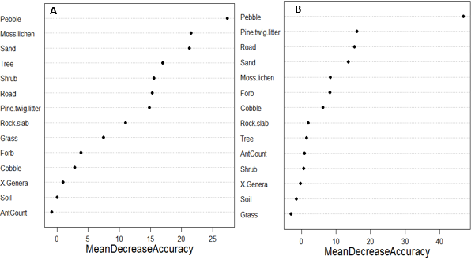
Figure 3: Importance plots for variables associated with models predicting presence of northern barrens tiger beetles. A) Predictor variables from habitat plots within Sam’s Point Preserve where northern barrens tiger beetles were detected and not detected. B) Predictor variables from habitat plots within Sam’s Point Preserve where northern barrens tiger beetles were detected and where they were not detected at locations within their historical range.

The most important variables for the within Sam’s Point Preserve model were pebble cover, moss/lichen, and sand percent cover, while the most important variables for the outside of Sam’s Point Preserve model were pebble, pine/twig, and road percent cover (Fig. 3). Both models resulted in a positive relationship with tiger beetle presence with increased pebble percent cover. In the within Sam’s Point preserve model, moss/lichen and sand percent cover had positive relationships with plots where tiger beetles were detected. In the outside of Sam’s Point Preserve model, increased percent cover of pine/twig litter decreased the likelihood of northern barrens tiger beetles, however road percent cover positively influenced beetle detection until ~80% cover was reached wherein the relationship turned strongly negative.
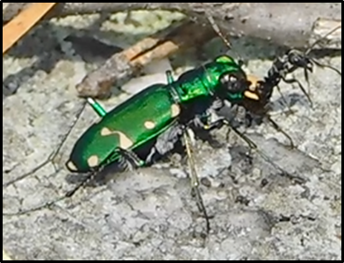
Surprisingly, ant abundance and H’ diversity were not important variables in any model. In plots where tiger beetle adults were detected there was a mean of 2.3 ± 3.7 ants and in non-detected areas, 2.4 ± 4.9 (p_{1.66},₈₈ = 0.16). Six kinds of ants were detected; carpenter, cocktail, odorous, wood, shampoo, and moisture ants. All six kinds were present at plots where tiger beetles were not detected, whereas only carpenter ants, wood ants, and moisture ants were present at positive tiger beetle plots. These genera of ants share the same subfamily of Formicinae, and these ants have an acidopore (a structure at the end of their seventh abdominal segment that can spray formic acid in defense at their enemies), but have no functional sting (Ward et al. 2016). Cocktail and shampoo ants have well developed stings, while odorous ants lack stings. Instead of a sting, odorous ants use pungent odors from an anal gland to ward of predators (Welzel et al. 2018). Ants present in areas where adult tiger beetles were detected are larger than those in areas where tiger beetles were not detected. Beetles could select areas with larger prey items due to increased visibility of the larger prey and increased nutrient intake per prey item for less effort (Fig. 4).
Figure 4: Northern barrens tiger beetle individual consuming a carpenter ant.

Conclusions

This population of rare tiger beetle is likely limited by habitat variables related to female oviposition behavior. Possible habitat characteristics causing extirpation of these beetles from areas outside of Sam’s Point Preserve are decreased cover of pebbles and increased cover of pine/twig litter. Variables keeping beetles from dispersing to similar nearby areas are lack of pebble, moss/lichen, and sand cover.
To ensure this population does not become extirpated, management actions should be taken to keep increased pebble cover and decreased pine/twig litter cover. To increase the likelihood of successful dispersal to neighboring areas, Sam’s Point Preserve could partner with surrounding areas (e.g., Mohonk, Minnewaska Park) to take actions to preserve or restore pebble, moss/lichen, and sand cover by creating/supporting natural openings. Patron foot traffic should also avoid areas where there are known larval burrows to decrease the risk of soil compaction. Areas of interest for new trails should be scouted to ensure they are not located in tiger beetle habitat.
Monitoring should be continued at Sam’s Point Preserve for this rare species. Since this research was only over two years, mark-recapture should be continued until the annual variation of population size is understood. Once annual variation is understood, it would be possible to shift monitoring effort to occupancy surveys. This would allow for park staff to still monitor the population, but with less effort.

Acknowledgments

This work could not have been completed without the advice and support of Melissa Fierke, Dylan Parry, and Matthew Schlesinger. I would also like to thank the staff of Sam’s Point Preserve for allowing me to conduct this research in the preserve. I owe a huge thank you to my wonderful field technician, Christian Chevalier, who made the most of counting and collecting ants. This work was made possible by the generous support of the Edna Baily Sussman Foundation.

Literature Cited

Beers, A., J. Hall, W. Janeway, and T. Dooley. 2011. Northern Shawangunk Ridge fire management plan. Interagency fire management plan for Minnewaska State Park Preserve, Sam’s Point Preserve, Mohonk Preserve and Witch’s Hole State Forest, New Paltz, New York.
Ellison, A.M., N.J. Gotelli, E.J. Farnsworth, and G.D. Alpert. 2012. A field guide to the ants of New England. Yale University Press, New Haven, Connecticut, USA.
Mawdsley, J.R. 2005. Extirpation of a population of Cicindela patruela Dejean (Coleoptera: Carabidae: Cicindelini) in suburban Washington, D.C., USA. Proc. Entomol. Soc. Wash. 107:64–70.
Hudgins, R.M., C. Norment, M.D. Schlesinger, and P.G. Novak. 2011. Habitat selection and dispersal of the cobblestone tiger beetle (Cicindela marginipennis Dejean) along the Genesee River, New York. American Midland Naturalist 165:304–318.
New York Natural Heritage Program. 2017. Online conservation guide for Cicindela patruela patruela. http://acris.nynhp.org/guide.php?id=37144.
Schlesinger, M.D., and P.G. Novak. 2011. Status and conservation of an imperiled tiger beetle fauna in New York State, USA. Journal of Insect Conservation 15:839–852.
Ward, P.S., B.B. Blaimer, and B.L. Fisher. 2016. A revised phylogenetic classification of the ant subfamily Formicinae (Hymenoptera: Formicidae), with resurrection of the genera Colobopsis and Dinomyrmex. Zootaxa, 4072(3), 343–357.
Welzel, K.F., S.H. Lee, A.T. Dossey, K.R. Chauhan, and D.H. Choe. 2018. Verification of Argentine ant defensive compounds and their behavioral effects on heterospecific competitors and conspecific nestmates. Scientific reports 8.1:1477.

