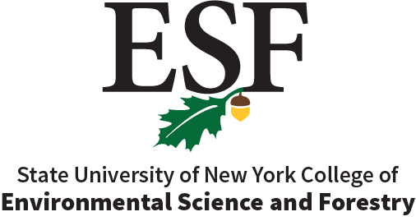
Academic Affairs Committee

Agenda for November 11, 2025 Meeting 11 AM
252 Marshall Hall
or
Zoom: https://syracuseuniversity.zoom.us/j/97417812544?pwd=QXJQSGtSSUlVaWd6cFVYczVINlVoQT09

Meeting ID: 974 1781 2544
Passcode: 928047

- Call to Order
- Updates from the Associate Provost
- New Course Proposal form posted
- Chair report
  - General Education
- Administrative Approvals
  - Course Revision EFB 523 Tropical Ecology
  - Curriculum Revision MS Environmental Biology
  - Curriculum Revision MS Environmental Science
  - Course Revision EFB 899 Master Research
  - Course Revision ENS 899 Master Research

- New Business
  - Curriculum Revision MPS Ecological Restoration
  - Policy Revision- Posthumous Degree
  - New Course proposal EST 206 Comics and the Drawn Environment
  - New Minor proposal Civic Engineering Technology
  - Course Revision EFB 423 Marine Ecology
  - Course Revision EFB 623 Marine Ecology
  - Course Revision ESF 797 Grad Seminar in Research, Writing, and Resources

Upcoming meeting:
December 9, 2025

